Computer on Wheels



**By:**

**Bilal Rafiq**

**27661**

**Hamza Azhar**

**28595**

**Sardar Mohsin Saghir**

**28016**

**M. Usama Nazir**

**30445**

**Supervised by:**

**Dr. Naveed Ikram**

**Faculty of Computing**

**Riphah International University, Islamabad**

**Fall 2024A Dissertation Submitted To**

**Faculty of Computing,**

**Riphah International University, Islamabad**

**As a Partial Fulfilment of the Requirement for the Award of the Degree of**

**Bachelors of Science in Software Engineering**

**Faculty of Computing**

**Riphah International University, Islamabad**

Date: 5th November, 2024**Final Approval**

This is to certify that we have read the report submitted by ***Bilal Rafiq (27661), Hamza Azhar (28595), Sardar Mohsin Saghir (28016) and M. Usama Nazir (30445),*** for the partial fulfilment of the requirements for the degree of the Bachelors of Science in Software Engineering (BSSE). It is our judgment that this report is of sufficient standard to warrant its acceptance by Riphah International University, Islamabad for the degree of Bachelors of Science in Software Engineering (BSSE).

**Committee:**

|  |  |
| --- | --- |
| **1** | Dr. Naveed Ikram  (Supervisor) |
|  |  |
| **2** | Dr. Musharraf Ahmed  (Head of Department/chairman) |

**Declaration**

We hereby declare that this document “**Computer on Wheels**” neither as a whole nor as a part has been copied out from any source. It is further declared that we have done this project with the accompanied report entirely on the basis of our personal efforts, under the proficient guidance of our teachers, especially our supervisors **Dr.** **Naveed Ikram** and **Dr. Rizwan Bin Faiz**. If any part of the system is proved to be copied out from any source or found to be the reproduction of any project from anywhere else, we shall stand by the consequences.

**___________________________**

**Bilal Rafiq**

**26771**

**___________________________**

**Hamza Azhar**

**28595**

**___________________________**

**Sardar Mohsin Saghir**

**28016**

**___________________________**

**M. Usama Nazir**

**30445**

**Dedication**

We dedicate this project to Allah Almighty our creator, our strong pillar, our source of

inspiration, wisdom, knowledge and understanding. He has been the source of our strength throughout this program. Also, we dedicate our work to our family, friends and

teachers. The unrivalled encouragement from our parents and outstanding support from teachers is what led to the success of this project. We also dedicate our work to our supervisors **Dr. Naveed Ikram, Dr. Rizwan Bin Faiz, Maanz AI** for their guidance and support and the faculty members.

**Acknowledgement**

Firstly, we are obliged to Allah Almighty the Merciful, the Beneficent, and the source of all Knowledge, for granting us the courage and knowledge to complete this Project.

We are grateful to our supervisors **Dr. Naveed Ikram and Dr. Rizwan Bin Faiz** for their enthusiasm, patience, insightful comments, helpful information, practical advice, and unceasing ideas that always helped us tremendously in our project. Without their support and guidance, this project would not have been possible. Also, a special thanks to **Maanz AI**, the faculty members, and **Mr. M. Tahir Anis**, an alumnus, for their invaluable support.

**___________________________**

**Bilal Rafiq**

**26771**

**___________________________**

**Hamza Azhar**

**28595**

**___________________________**

**Sardar Mohsin Saghir**

**28016**

**___________________________**

**M. Usama Nazir**

**30445**

**Abstract**

The emergence of Autonomous Vehicles (AVs) promises to revolutionize transportation by enhancing safety and efficiency. However, challenges such as human-error accidents and productivity loss during travel remain significant. This project aims to address these challenges by developing an **embedded software system for an autonomous vehicle designed for private use**, focusing on user-selected destinations. The system incorporates key functionalities, including **path following, path planning, obstacle detection and avoidance, and traffic light management.**

Utilizing machine learning for obstacle detection, the system enhances the vehicle's capabilities to navigate urban environments with precision and safety. Leveraging the **CARLA simulator for realistic vehicle simulations and ROS Noetic for robotic system** development, this project offers a novel approach to self-driving technology. The advancements in AVs by companies such as Tesla, Waymo, and Uber are paving the way for a future of transportation that promises increased global efficiency, safety, and security, which this project aims to contribute to through a robust software solution.

**Table of Contents**

Chapter 1: Introduction 14

1.1 Opportunity and Stakeholder 14

1.2 Motivations and Challenges 15

1.3 Goals and Objectives 15

1.4 Solution Overview 16

1.5 Report Outline 18

1.5.1 Chapter 1 18

1.5.2 Chapter 2 18

1.5.3 Chapter 3 18

1.5.4 Chapter 4 18

1.5.5 Chapter 5 18

1.5.6 Chapter 6 18

Chapter 2: Literature/Market Survey 20

2.1 Introduction 20

2.2 Literature Review / Technology Overview 20

2.3 Existing Systems 22

2.4 Summary 23

Chapter 3: Requirement Engineering 25

3.1 Introduction 25

3.2 Problem Scenarios 25

3.3 Key Concepts and Terminology 27

3.4 Functional Requirements 28

3.5 Non-Functional Requirement 38

3.6 SQA activity: Defect Identification: Inspection Thought Checklist 40

Chapter 4: System Design 47

4.1 Introduction 47

4.2 Architectural Design 48

4.3 Detailed Design 49

4.3.1 Use Case Design 49

4.3.2 Sequence Diagram 50

4.3.3 System State chart Diagram 51

4.4 SQA activity: State-Based Defect Detection Scenarios 61

Chapter 5: Implementation 70

5.1 Endeavour 70

5.2 Proposed Solution 84

5.3 Components and Libraries 84

5.4 IDE, Tools, Technologies and Development Platform 85

5.5 Best Practices / Coding Standards 86

5.6 Deployment Environment 89

5.7 SQA activity: Defect Detection Through White Box Testing 90

5.8 Summary 99

Chapter 6: Conclusion and Outlook 101

6.1 Introduction 101

6.2 Achievements and Improvements 101

6.3 Critical Review 102

6.4 Future Recommendations/Outlook 103

6.5 Summary 104

References and Bibliography 105

Appendices 106

Appendix-A: Software Requirements Specifications (SRS) 106

Appendix-B: Design Artifact 106

Appendix-C: Coding Standards/Conventions 106

Appendix-D: SQA Activities 106

Appendix-E: Work Breakdown Structure 106

Appendix-F: Roles & Responsibility Matrix 106

# 

**List of Figures**

|  |  |  |
| --- | --- | --- |
| 4.1 | Architecture Diagram | 48 |
| 4.2 | Use-case Diagram | 49 |
| 4.3 | Sequence diagram | 50 |
| 4.4 | System state chart diagram | 51 |
| 4.5 | Path Planning State Chart diagram | 52 |
| 4.6 | Path Following State Chart diagram | 53 |
| 4.7 | Vehicle Control State Chart diagram | 54 |
| 4.8 | Localization State Chart diagram | 55 |
| 4.9 | Perception State Chart diagram | 56 |
| 4.10 | Obstacle Detection and avoidance State Chart diagram | 57 |
| 4.11 | Error Handling and Recovery State Chart diagram | 58 |
| 4.12 | Traffic Light Detection State Chart diagram | 59 |
| 4.13 | Simulation Integration State Chart diagram | 60 |
| 5.1 | Proposed Solution | 84 |
| 5.5 | Deployment diagram | 89 |

# 

**List of Tables**

|  |  |  |
| --- | --- | --- |
| 2.1 | Levels of taxonomy | 21 |
| 2.2 | Existing Systems | 22 |
| 3.1 | problem statement 1 | 25 |
| 3.2 | problem statement 2 | 26 |
| 3.3 | problem statement 3 | 26 |
| 3.4 | FR1 | 28 |
| 3.5 | FR2 | 29 |
| 3.6 | FR3 | 30 |
| 3.7 | FR4 | 31 |
| 3.8 | FR5 | 32 |
| 3.9 | FR6 | 32 |
| 3.10 | FR7 | 33 |
| 3.11 | FR8 | 34 |
| 3.12 | FR9 | 34 |
| 3.13 | FR10 | 35 |
| 3.14 | FR11 | 36 |
| 3.15 | NFR1 | 38 |
| 3.16 | NFR2 | 38 |
| 3.17 | NFR3 | 39 |
| 3.18 | Inspection Table 1 | 40 |
| 3.19 | Inspection Table 2 | 40 |
| 3.20 | Inspection Table 3 | 41 |
| 3.21 | Inspection Table 4 | 41 |
| 3.22 | Inspection Table 5 | 42 |
| 3.23 | Inspection Table 6 | 42 |
| 3.24 | Inspection Table 7 | 43 |
| 3.25 | Inspection Table 8 | 43 |
| 3.26 | Inspection Table 9 | 44 |
| 3.27 | Inspection Table 10 | 45 |
| 4.1 | State-Based TC1 | 61 |
| 4.2 | State-Based TC2 | 62 |
| 4.3 | State-Based TC3 | 62 |
| 4.4 | State-Based TC4 | 63 |
| 4.5 | State-Based TC5 | 64 |
| 4.6 | State-Based TC6 | 65 |
| 4.7 | State-Based TC7 | 66 |
| 4.8 | State-Based TC8 | 67 |
| 4.9 | State-Based TC9 | 68 |
| 5.1 | Responsibilities Assignment Matrix | 75 |

|  |  |  |
| --- | --- | --- |
|  |  |  |
| 5.1 | Responsibilities Assignment Matrix | 82 |
| 5.2 | White Box TC1 | 104 |
| 5.3 | White Box TC2 | 105 |
| 5.4 | White Box TC3 | 106 |
| 5.5 | White Box TC4 | 106 |
| 5.6 | White Box TC5 | 107 |
| 5.7 | White Box TC6 | 108 |
| 5.8 | White Box TC7 | 109 |
| 5.9 | White Box TC8 | 109 |
| 5.10 | White Box TC9.1 | 110 |
| 5.11 | White Box TC9.2 | 110 |
| 5.12 | White Box TC10 | 111 |
| 5.13 | White Box TC11 | 112 |

**Chapter 1:**

**Introduction**

# Chapter 1: Introduction

**Computer on Wheels** is an **embedded software system designed for personal vehicles** that can autonomously navigate with minimal human intervention. The system controls the vehicle's movement capabilities, including throttle, acceleration, braking, and steering. It incorporates obstacle detection mechanisms to detect and respond to obstacles, ensuring safe navigation. Additionally, path planning algorithms are utilized to calculate optimal routes from a **user-specified** starting point to a destination. By leveraging cutting-edge technologies such as the **CARLA (Car Learning to Act) simulator**, the **CARLA-ROS bridge**, and **ROS (Robot Operating System)**, this project aims to create a robust **embedded software solution that empowers personal vehicles** to navigate urban environments confidently.

## 1.1 Opportunity and Stakeholder

* According to a **National Highway Traffic Safety Administration (NHTSA)** study, driver error led to **94% of the crashes** examined.
* According to the **U.S. General Services Administration (GSA)**, human error causes **98% of crashes**.
* A 2017 study by **RAND Corporation** found that self-driving cars could reduce traffic fatalities by up to **25% by 2040**.
* A 2019 study by the National Highway Traffic Safety Administration (NHTSA) found that self-driving cars were involved in fewer crashes than human-driven cars per mile driven.
* A 2020 study by the **Massachusetts Institute of Technology (MIT)** found that self-driving cars could **prevent up to 90%** of crashes caused by human error.
  + 1. **Stakeholders**
* Driver
* Passengers
* Vehicle Owner

## Motivations and Challenges

Our project is motivated by the importance of enhancing safety for passengers, drivers, and pedestrians through autonomous vehicle technology. By alleviating the need for human drivers, we aim to enable multitasking and provide independence to individuals, including those with disabilities. Challenges such as time management and acquiring a physical model car for demonstrations were overcome by transitioning to the CARLA simulator. However, **GPU resource limitations were encountered**, which were addressed through assistance from **Maanz AI**, securing workspace and expert guidance.

## Goals and Objectives

**Our goals are clear**: complete the project on time while ensuring high-quality deliverables and develop autonomous vehicle software to eliminate accidents caused by human error and enhance mobility for individuals with disabilities. These objectives will minimize errors, boost stakeholder productivity, and provide mobility for aged persons and people having disabilities.

## Solution Overview

Our solution involves developing an embedded software system for autonomous vehicles that utilizes advanced technologies, including the CARLA simulator, ROS Noetic, the CARLA-ROS bridge, and rospy. This software enables vehicles to navigate complex environments autonomously by implementing the following key functionalities:

* **Path Planning**: Determining optimal routes from user-specified locations.
* **Path Following**: Ensuring precise vehicle navigation along the planned trajectory.
* **Obstacle Detection**: Detecting objects in the vehicle's surroundings using sensor data.
* **Obstacle Avoidance**: Executing dynamic maneuvers to circumvent detected obstacles safely.
* **Traffic Light Detection and Response**: Identifying traffic lights using sensor data, recognizing their states (red, yellow, green), and making informed decisions about vehicle behavior based on these signals.

By focusing on safety and precision, the solution aims to minimize accidents caused by human error. Through rigorous development and extensive testing, we aspire to deliver a reliable and efficient solution that revolutionizes autonomous vehicle navigation.

* + 1. **Project Scope**

The scope of this project encompasses the development and implementation of key functionalities:

* + - 1. **Integration**
* Involve integrating various sensors and algorithms to enable the vehicle to perceive its environment accurately, make decisions, and navigate safely through dynamic scenarios.
  + - 1. **Path Planning:**
* Determining a feasible and shortest path from user-specified source and destination locations
* Implementing a navigation algorithm to handle dynamic environments and potential rerouting.
  + - 1. **Path Following:**
* Implementing control algorithms for precise vehicle guidance along the planned trajectory.
* Maintaining vehicle position and orientation relative to the path using steering, acceleration, and braking control.
  + - 1. **Obstacle Detection:**
* Utilizing sensor data (such as lidar, radar or cameras) to detect objects within the vehicle's surroundings.
* Providing real-time information about detected obstacles to inform path planning and navigation decisions.
  + - 1. **Obstacle avoidance:**
* Implement reactive obstacle avoidance strategies, allowing the autonomous vehicle to dynamically adjust its trajectory based on the detected obstacles, enabling safe navigation.
* Implement algorithms/maneuver for real-time analysis of obstacle data to facilitate swift decision-making by the autonomous vehicle.
  + - 1. **Traffic Light Detection and Response**
* Utilizing sensor data to detect the presence of traffic lights at intersections.
* Recognizing the state of traffic lights (red, yellow, green) and adjusting vehicle behavior accordingly, including stopping, slowing down, or proceeding through intersections safely.

## Report Outline

This report covers all aspects of the Computer on Wheels, for understanding and clarity. This report has been divided into six chapters.

### Chapter 1

This chapter serves as an introduction to our software system, encapsulating the project's opportunities, stakeholders, motivations, challenges, goals, objectives, and the proposed solution.

### Chapter 2

This chapter undertakes a thorough examination of existing literature pertaining to autonomous vehicles, alongside an analysis of companies operating within this domain.

### Chapter 3

This chapter outlines the essential requirements that serve as the foundation for guiding the development process and ensuring that the system meets the needs and expectations of stakeholders and end-users.

### Chapter 4

This chapter comprehensively covers the design factors of the developed system, focusing on system architecture design considerations and various diagrams modelling the working behaviour of the system.

### Chapter 5

This chapter includes the implementation process of our project, outlining the steps taken to achieve our goals and the integration of technologies and methodologies to ensure the successful development of our project.

### Chapter 6

This chapter includes the conclusion of our project, along with a brief outlook

Chapter 2:

**Literature/Market Survey**

# Chapter 2: Literature/Market Survey

This chapter provides an overview of the current state of autonomous vehicles (AVs), including existing developments, ongoing testing, and prominent market participants. It explores the origins of autonomous vehicles and the regulatory bodies responsible for establishing rules governing their deployment.

## Introduction

The concept of autonomous vehicles is well-established in the automotive industry. Companies such as Tesla, General Motors, BMW, Mercedes, Honda, KIA, and Toyota have been actively engaged in the development of AV technologies. Many have equipped vehicles with Level 2 and Level 3 autonomous systems, although not all of these have been released to the market. The Society of Automotive Engineers (SAE) has established six levels of driving automation, ranging from Level 0 (fully manual) to Level 5 (fully autonomous), providing a framework for understanding the capabilities of these systems.

## Literature Review / Technology Overview

The concept of autonomous vehicles dates back to 1918, with early attempts emerging in the 1920s. General Motors was among the pioneers, showcasing autonomous vehicle concepts at exhibitions. Significant momentum in research and development came from initiatives such as the collaboration between General Motors and RCA Sarnoff Laboratory. The Defense Advanced Research Projects Agency (DARPA) Grand Challenges Program in 2004 further accelerated research in the US.

Today, the global autonomous vehicle market features key players including AB Volvo, BMW AG, Daimler AG, Ford Motor Company, General Motors, Honda Motor Co., Ltd., Nissan Motors Co., Ltd., Tesla, Inc., Toyota Motor Corporation, and Volkswagen AG.

* **AB Volvo**: Began developing autonomous vehicles in 2006 and unveiled a fully autonomous test vehicle in 2017, though commercial availability is still pending.
* **Waymo (Google's subsidiary)**: Has logged millions of autonomous driving miles and currently offers limited commercial self-driving ride-hailing services in select locations.
* **Tesla**: Announced plans for self-driving features in their cars in 2014. However, Tesla's Autopilot is a driver-assistance system rather than fully autonomous and has faced safety criticisms.
  + 1. **Levels of Autonomous Vehicles**

Understanding the different levels of autonomy set by the Society of Automotive Engineers (SAE) International is crucial before discussing existing autonomous vehicle systems. These levels explain how much control the vehicle has versus the human. The table below shows these levels, from full human control to full automation, making it easier to understand the capabilities of existing systems.

*Table 2.1: Levels of taxonomy*

|  |  |
| --- | --- |
| **Levels of Taxonomy** | **Description** |
| **Level 0**  No automation | Zero autonomy; the driver performs all driving tasks. |
| **Level 1**  Driver assistance | The vehicle is controlled by the driver but driving assist features may be included in the vehicle design. |
| **Level 2**  Partial automation | Vehicles have combined automated functions, like acceleration and steering, but the driver must remain engaged with the driving task and always monitor the environment. |
| **Level 3**  Conditional automation | A driver is a necessity but is not required to monitor the environment. The driver must be ready to always take control of the vehicle with notice. |
| **Level 4**  High automation | The vehicle can perform all driving functions under certain conditions. The driver may have the option to control the vehicle. |
| **Level 5**  Full automation | The vehicle can perform all driving functions under all conditions. |

## Existing Systems

*Table 2.2: Existing Systems*

|  |  |  |
| --- | --- | --- |
| **Company** | **Target Level** | **Key Features** |
| **Tesla, Ford, Toyota** | Level 2 (Autopilot) | * Lane keeping * automatic emergency braking * traffic light and stop sign recognition * highway driving assist * self-parking (Level 2) * Navigate on Autopilot |
| **BMW, Nissan** | Level 2 | * Adaptive cruise control with stop-and-go * lane departure warning * lane change assist |
| **Honda, Mercedes-Benz** | Level 3 (conditional) | * Hands-free driving at up to 60 km/h on specific highways * automatic lane changes * traffic jam assist * emergency stop assists |
| **Way-mo** | Level 4 | * LiDAR-based system for navigating complex * extensive real-world testing * millions of miles driven |
| **Cruise** | Level 5 | * Fully autonomous robo-taxi |

Currently, the automotive market provides vehicles with Levels 0, 1, and 2 of automation. Levels 3, 4, and 5 are still in the **testing phase** and not widely available for commercial use.

## Summary

This chapter analyzes the current landscape of autonomous vehicles (AVs). While various companies are actively developing AV technology, commercially available vehicles primarily offer Levels 0 (no automation), 1 (driver assistance features), and 2 (partial automation) of driving autonomy as defined by the Society of Automotive Engineers (SAE). Levels 3 (conditional automation), 4 (high automation), and 5 (full automation) remain under development and testing.

Chapter 3:

**Requirement Analysis**

# Chapter 3: Requirement Engineering

## Introduction

In this chapter we will discuss the requirements of our project “Computer on Wheels”. Prior to that, we will discuss all the problem statements we have found while doing research on the project idea. These requirements are gathered using a variety of techniques, including **interviewing domain experts** and **conducting documentation analysis**. Our approach involves reviewing **existing documentation, research papers, industry standards, and guidelines** related to autonomous vehicle navigation.

## Problem Scenarios

*Table 3.1: problem statement 1*

|  |  |
| --- | --- |
| **Problem Statement # 1: Safety Challenges** | |
| The problem of | Inadequate safety measures for autonomous navigation in adverse weather conditions. |
| Affects | Passengers, pedestrians and other road users. |
| The result of which | Increased risk of accidents due to reduced visibility, leading to injuries or fatalities. |
| Benefits of | Improved safety protocols to ensure reliable operation of autonomous vehicles in varying environmental conditions. |

*Table 3.2: problem statement 2*

|  |  |
| --- | --- |
| **Problem Statement # 2: Challenges in Simulation for AV Software Development** | |
| The problem of | Inadequate utilization of simulation environments (CARLA) for developing and validating ROS-based autonomous vehicle software. |
| Affects | Developers and researchers in autonomous vehicle systems. |
| The result of which | Slower development cycles, higher costs of physical testing, and potential safety risks due to insufficient validation. |
| Benefits of | Enhanced efficiency and safety through thorough evaluation of autonomous algorithms under varied conditions before deployment. |

*Table 3.3: problem statement 3*

|  |  |
| --- | --- |
| **Problem Statement # 3: User Acceptance Challenges for Autonomous Vehicles.** | |
| The problem of | Limited user acceptance of autonomous vehicle technology due to perceived safety and reliability concerns. |
| Affects | Potential users, stakeholders, and the overall adoption of autonomous vehicles. |
| The result of which | Resistance to adopting autonomous vehicles, leading to slower market penetration and reduced investment in further development and innovation. |
| Benefits of | Building user confidence through improved transparency, education, and demonstrations of safety features in various conditions, which can enhance the acceptance and integration of autonomous vehicles in everyday life. |

## ****Key Concepts and Terminology****

To understand the requirements outlined in this chapter, it is important to be familiar with certain key concepts related to the **Robot Operating System (ROS)**, which serves as the framework for our embedded system.

* + 1. **ROS Overview**

The Robot Operating System (ROS) is a middleware framework that is essential for managing complex data exchanges in autonomous systems like our **"Computer on Wheels."** It provides tools for creating **modular software components**, called **nodes**, that can communicate over defined channels known as **topics**.

* + 1. **ROS Nodes**

Nodes are software modules that perform specific tasks. For example, a sensor node may detect obstacles, while a control node manages vehicle movement.

* + 1. **ROS Topics**

Topics are the communication channels between nodes. Each topic is defined for a specific type of data exchange, such as publishing sensor readings or receiving control commands.

* + 1. **ROS Messages**

Messages are the data structures used to communicate information over ROS topics. Each message type has a defined format and is used to transmit specific types of data, such as position coordinates or sensor measurements.

* + 1. **ROS Services**

Services provide a way for nodes to request specific actions or information from each other, such as recalculating a path when an obstacle is detected.

This foundational understanding of ROS will facilitate comprehension of the requirements detailed in the subsequent sections.

## Functional Requirements

* + 1. **Vehicle Control:**

*Table 3.4: FR1*

|  |  |  |  |  |
| --- | --- | --- | --- | --- |
| **No** | **Functional Requirement** | **Breakdown** | | **Description** |
| **ID** | **Sub-Functionality** |
| **1** | **Vehicle Control** | **1.1** | Autonomous Navigation | The system shall be capable of autonomously navigating from a starting point to a destination using ROS-based navigation stacks. |
| **1** | **Vehicle Control** | **1.2** | Acceleration Control | The system shall control the vehicle's acceleration to maintain desired speeds along the planned trajectory, publishing commands to the topics in ROS. |
| **1** | **Vehicle Control** | **1.3** | Emergency Stop | The system shall include a mechanism for the driver to perform an immediate emergency stop, halting all vehicle operations by publishing to the dedicated ROS topic (/emergency_stop) |
| **1** | **Vehicle Control** | **1.4** | Throttle Control | The system shall control the throttle to regulate vehicle speed within a range of 0 to 120 km/h, adjusting for road conditions and traffic regulations, using PID controller implemented in ROS. |
| **1** | **Vehicle Control** | **1.5** | Steering Control | The system shall control the vehicle's steering to maintain a maximum lateral deviation of 0.5 meters from the planned trajectory under normal conditions, using ROS control messages. |
| **1** | **Vehicle Control** | **1.6** | Braking Control | The system shall control the vehicle's braking to safely decelerate and stop as required by the planned trajectory, publishing braking commands to ROS topic. |

* + 1. **Path Planning:**

*Table 3.5: FR2*

|  |  |  |  |  |
| --- | --- | --- | --- | --- |
| **No** | **Functional Requirement** | **Breakdown** | | **Description** |
| **ID** | **Sub-Functionality** |
| **2** | **Path Planning** | **2.1** | Route Calculation | The system shall calculate the most efficient route i.e. shortest path from the vehicle's current location to the driver-specified destination using ROS-based algorithms. |
| **2** | **Path Planning** | **2.2** | Lane Assignment | The system shall assign appropriate lanes for the vehicle to travel in along the calculated route, based on legal navigation rule and map data. |
| **2** | **Path Planning** | **2.3** | Waypoint Generation | The system shall generate waypoints along the calculated route to guide the vehicle towards the destination, publishing waypoints to a ROS topic (/waypoints). |
| **2** | **Path Planning** | **2.4** | Dynamic Obstacle Avoidance | The system shall adapt the vehicle's path in real-time to safely avoid unexpected obstacles using ROS-based path adjustment algorithms. |
| **2** | **Path Planning** | **2.5** | Map Reading | The system shall be able to read and interpret digital map data using ROS to determine the vehicle's precise location within the road network |

* + 1. **Path Following:**

*Table 3.6: FR3*

|  |  |  |  |  |
| --- | --- | --- | --- | --- |
| **No** | **Functional Requirement** | **Breakdown** | | **Description** |
| **ID** | **Sub-Functionality** |
| **3** | **Path Following** | **3.1** | Path smoothing | The system shall apply path smoothing techniques to limit acceleration changes to within 0.3 m/s², ensuring a smooth ride for passengers. |
| **3** | **Path Following** | **3.2** | Lateral Control | The system shall maintain a lateral deviation of no more than 0.5 meters from the planned path under normal driving conditions using ROS control loops. |
| **3** | **Path Following** | **3.3** | Longitudinal Control | The system shall maintain a longitudinal deviation of no more than 1 meter from the planned path under normal driving conditions. |
| **3** | **Path Following** | **3.4** | Speed Control | The system shall control the speed to reach the destination. |
| **3** | **Path Following** | **3.5** | Waypoint Following | The system shall follow waypoints along the calculated route, using ROS topics to track progress towards each waypoint. |

* + 1. **Sensor Integration:**

*Table 3.7: FR4*

|  |  |  |  |  |
| --- | --- | --- | --- | --- |
| **No** | **Functional Requirement** | **Breakdown** | | **Description** |
| **ID** | **Sub-Functionality** |
| **4** | **Sensor Integration** | **4.1** | Inertial Measurement Unit Utilization | The system shall use an IMU to provide orientation and acceleration data at a frequency of 100 Hz, publishing data to ROS topics. |
| **4** | **Sensor Integration** | **4.2** | Global Positioning System Utilization | The system shall use GPS to determine the vehicle’s position and publish coordinates to a ROS topic (/gps_data). |
| **4** | **Sensor Integration** | **4.3** | Radar/Lidar Utilization | The system shall utilize radar/lidar sensors to provide information about surrounding objects' velocity and distance, enhancing situational awareness through ROS topics |

* + 1. **Trajectory Planning:**

*Table 3.8: FR5*

|  |  |  |  |  |
| --- | --- | --- | --- | --- |
| **No** | **Functional Requirement** | **Breakdown** | | **Description** |
| **ID** | **Sub-Functionality** |
| **5** | **Trajectory Planning** | **5.1** | Trajectory Generation | The system shall plan a smooth and optimal trajectory, based on destination specified by user. |

* + 1. **Obstacle Detection:**

*Table 3.9: FR6*

|  |  |  |  |  |
| --- | --- | --- | --- | --- |
| **No** | **Functional Requirement** | **Breakdown** | | **Description** |
| **ID** | **Sub-Functionality** |
| **6** | **Obstacle Detection** | **6.1** | Detection Using Sensors | The system shall utilize various sensors to detect obstacles in the vehicle's path, integrating data through ROS topics (/obstacle_detection). |
| **6** | **Obstacle Detection** | **6.2** | Environmental Awareness | The system shall maintain awareness of static and dynamic objects in the vehicle’s vicinity, using ROS-based perception modules. |
| **6** | **Obstacle Detection** | **6.3** | Dynamic Obstacle Tracking | The system shall continuously track moving obstacles, updating their positions through ROS messages. |
| **6** | **Obstacle Detection** | **6.4** | Destination Estimation | The system shall calculate the distance to detected obstacles and publish this data to a ROS topic (/distance_to_obstacle). |

* + 1. **Obstacle Avoidance:**

*Table 3.10: FR7*

|  |  |  |  |  |
| --- | --- | --- | --- | --- |
| **No** | **Functional Requirement** | **Breakdown** | | **Description** |
| **ID** | **Sub-Functionality** |
| **7** | **Obstacle Avoidance** | **7.1** | Maneuver Execution | The system shall execute safe and efficient avoidance maneuvers to navigate around detected obstacles, using ROS-based planning and control. |
| **7** | **Obstacle Avoidance** | **7.2** | Steering Control | The system shall dynamically adjust steering angles to guide the vehicle away from obstacles, keeping it on its intended path using ROS. |
| **7** | **Obstacle Avoidance** | **7.3** | Re-Plan Path | The system shall re-plan the path once an obstacle is detected, updating the path through ROS services. |
| **7** | **Obstacle Avoidance** | **7.4** | Trajectory Adjustment | The system shall dynamically adjust the vehicle’s trajectory to avoid obstacles in a clear environment using ROS algorithms. |
| **7** | **Obstacle Avoidance** | **7.5** | Multi-Obstacle Handling | The system shall manage avoidance of multiple obstacles simultaneously through ROS-based coordination. |

* + 1. **Destination Arrival:**

*Table 3.11: FR8*

|  |  |  |  |  |
| --- | --- | --- | --- | --- |
| **No** | **Functional Requirement** | **Breakdown** | | **Description** |
| **ID** | **Sub-Functionality** |
| **8** | **Destination Arrival** | **8.1** | Destination Approach | The system shall approach the driver-specified destination with a positional accuracy of within 1 meter, following the calculated trajectory and waypoints using ROS. |
| **8** | **Destination Arrival** | **8.2** | Stop at Destination | The system shall bring the vehicle to a complete stop within 1 meter of the designated destination, ensuring deceleration rates do not exceed 2 m/s² for passenger safety and comfort. |

* + 1. **User Inputs:**

*Table 3.12: FR9*

|  |  |  |  |  |
| --- | --- | --- | --- | --- |
| **No** | **Functional Requirement** | **Breakdown** | | **Description** |
| **ID** | **Sub-Functionality** |
| **9** | **User Inputs** | **9.1** | Ride Initiation | The system shall allow the user to initiate the autonomous driving process through a terminal command, which will start the ROS nodes required for vehicle navigation, control, and sensor integration. The command shall initiate the entire process of path planning, path following, and obstacle detection, ensuring all necessary components are activated before vehicle motion begins. |
| **9** | **User Inputs** | **9.2** | Destination Setting | The user shall be able to input the desired destination, triggering the route planning process through ROS services. |

* + 1. **System Integration:**

*Table 3.13: FR10*

|  |  |  |  |  |
| --- | --- | --- | --- | --- |
| **No** | **Functional Requirement** | **Breakdown** | | **Description** |
| **ID** | **Sub-Functionality** |
| **10** | **System Integration** | **10.1** | ROS Integration | The system shall utilize the Robot Operating System (ROS) to facilitate communication and data exchange between different software components. |
| **10** | **System Integration** | **10.2** | Simulation Environment | Development and testing of the system shall be conducted in a simulated environment (e.g., CARLA simulator) for thorough validation before real-world deployment. |

* + 1. **Traffic Light Module:**

*Table 3.14: FR11*

|  |  |  |  |  |
| --- | --- | --- | --- | --- |
| **No** | **Functional Requirement** | **Breakdown** | | **Description** |
| **ID** | **Sub-Functionality** |
| **11** | **Traffic Light Module** | **11.1** | **Traffic Light Detection** | The system shall detect traffic lights in the vehicle’s path using camera-based sensors and publish the detected traffic light information to a ROS topic (/traffic_light_detection). |
| **11** | **Traffic Light Module** | **11.2** | Traffic Light State Recognition | The system shall recognize the state of detected traffic lights (red, yellow, green) using image processing algorithms within a ROS node, publishing the identified state to a topic (/traffic_light_state). |
| **11** | **Traffic Light Module** | **11.3** | Decision-Making Based on Traffic Light State | The system shall adjust vehicle behavior (e.g., deceleration, stopping, or proceeding) based on the recognized traffic light state, using data from the /traffic_light_state topic. |
| **11** | **Traffic Light Module** | **11.4** | Red Light Handling | Upon detecting a red-light state, the system shall bring the vehicle to a complete stop at a safe distance i.e., 1 meter from the traffic light, ensuring smooth deceleration. |
| **11** | **Traffic Light Module** | **11.5** | Green Light Handling | Upon detecting a green light state, the system shall resume vehicle motion and proceed along the planned path. |
| **11** | **Traffic Light Module** | **11.6** | Yellow Light Handling | Upon detecting a yellow light state, the system shall determine whether it is safe to proceed based on vehicle speed and distance to the traffic light, either decelerating to a stop or proceeding through the intersection. |
| **11** | **Traffic Light Module** | **11.7** | Traffic Light State Uncertainty | If the system cannot detect a traffic light state for more than 2 seconds, it shall trigger a safe stop and log an error message to a ROS topic (/traffic_light_error). |

## Non-Functional Requirement

*Table 3.15: NFR1*

|  |  |  |  |  |
| --- | --- | --- | --- | --- |
| **No** | **Non- Functional Requirement** | **Subfactor** | **Verification Metric** | **Target Value** |
| **1** | **Safety Requirement** Ensure reliable object detection in adverse weather conditions to assure safety | **Hazard Protection** The system must detect and respond to hazards arising from adverse weather conditions, such as rain, fog, or snow, which may reduce visibility. | **Detection Accuracy:** Measure the percentage of correctly detected objects in various weather conditions.  **Response Time:** Time taken to respond to detected hazards.  **Test Cases:** Conduct tests in simulated environments with varying weather scenarios (e.g., rain, fog, snow) | **Detection Accuracy:** ≥ 90%  **Response Time:** ≤ 2 seconds in 95% of cases |

*Table 3.16: NFR**2*

|  |  |  |  |  |
| --- | --- | --- | --- | --- |
| **No** | **Non- Functional Requirement** | **Subfactor** | **Verification Metric** | **Target Value** |
| **2** | **Scalability Requirement** The ROS-based architecture shall support adding new sensors (e.g., radar, additional cameras) without significant changes to the core modules. | **System Expandability** | **Integration Time:** Measure the time taken to integrate a new sensor and update existing modules.  **Compatibility Tests:** Perform tests to ensure new sensors can be added without affecting existing functionality. **Modularity Assessment:** Analyze the architectural design for dependencies that may hinder expansion. | **Integration Time:** ≤ 10 minutes |

*Table 3.17: NFR3*

|  |  |  |  |
| --- | --- | --- | --- |
| **No** | **Non- Functional Requirement** | **Subfactor** | **Verification Metric** |
| **3.1** | **Modularity Requirement** The system shall maintain a modular ROS node structure, separating perception, planning, and control into distinct nodes for ease of testing and modification. | **Software Architecture** | **Node Independence:** Verify that each node can be tested independently without affecting others. **Modification Time:** Measure the time required to modify or update a specific node. |
| **3.2** | **Modularity Requirement** Each ROS node shall handle a specific task (e.g., path planning, obstacle detection) and communicate through well-defined ROS topics. | **Task Separation** | **Message Latency:** Measure the time taken for messages to be published and received between nodes (≤ 100 ms). **Task Success Rate:** Evaluate the success rate of individual nodes in completing their specific tasks (≥ 95%). |

## SQA activity: Defect Identification: Inspection Thought Checklist

* + 1. **Throttle Control:**

**Original:** The system shall control the throttle for regulation of vehicle speed.

**Revised:** The system shall control the throttle to regulate vehicle speed within a range of 0 to 120 km/h, adjusting for road conditions and traffic regulations.

*Table 3.18: Inspection Table 1*

|  |  |  |
| --- | --- | --- |
| **Requirement** | **Check List Point** | **Defect** |
| The system shall control the throttle for regulation of vehicle speed. | Verifiability: Is each requirement testable or verifiable? | The requirement lacks specifics on the range of speed control and conditions under which speed regulation should be adjusted. |

* + 1. **Steering Control:**

**Original:** The system shall control the vehicle's steering to follow the planned trajectory accurately.

**Revised:** The system shall control the vehicle's steering to maintain a maximum lateral deviation of 0.5 meters from the planned trajectory under normal conditions.

*Table 3.19: Inspection Table 2*

|  |  |  |
| --- | --- | --- |
| **Requirement** | **Check List Point** | **Defect** |
| The system shall control the vehicle's steering to follow the planned trajectory accurately. | Clarity: Are the requirements stated clearly so there is only one interpretation? | The term "accurately" is vague and not quantifiable. |

* + 1. **Route Calculation:**

**Original:** The system shall calculate the most efficient route i.e. shortest path from the vehicle's current location to the driver-specified destination.

**Revised:** The system shall calculate the most efficient route i.e. shortest path from the vehicle's current location to the driver-specified destination

*Table 3.20: Inspection Table 3*

|  |  |  |
| --- | --- | --- |
| **Requirement** | **Check List Point** | **Defect** |
| The system shall calculate the most efficient route from the vehicle's current location to the driver-specified destination. | Verifiability: Does each requirement use concrete terms and measurable quantities? | "Most efficient route" is not defined; efficiency could refer to time, distance, fuel consumption, etc. |

* + 1. **Path Smoothing:**

**Original:** The system shall apply path smoothing techniques to reduce jerkiness and ensure passenger comfort.

**Revised:** The system shall apply path smoothing techniques to limit acceleration changes to within 0.3 m/s², ensuring a smooth ride for passengers.

*Table 3.21: Inspection Table 4*

|  |  |  |
| --- | --- | --- |
| **Requirement** | **Check List Point** | **Defect** |
| The system shall apply path smoothing techniques to reduce jerkiness and ensure passenger comfort. | Verifiability: Is each requirement testable or verifiable? | The requirement does not define what constitutes "jerkiness" or acceptable levels of passenger comfort. |

* + 1. **Lateral Deviation:**

**Original:** The system shall minimize the lateral deviation from the path.

**Revised:** The system shall maintain a lateral deviation of no more than 0.5 meters from the planned path under normal driving conditions.

*Table 3.22: Inspection Table 5*

|  |  |  |
| --- | --- | --- |
| **Requirement** | **Check List Point** | **Defect** |
| The system shall minimize the lateral deviation from the path. | Clarity: Are the requirements written in user language? Do the users think so? | "Minimize" is not quantified; specific acceptable deviation limits should be stated. |

* + 1. **Longitudinal Deviation:**

**Original:** The system shall minimize the Longitudinal deviation from the path.

**Revised:** The system shall maintain a longitudinal deviation of no more than 1 meter from the planned path under normal driving conditions.

*Table 3.23: Inspection Table 6*

|  |  |  |
| --- | --- | --- |
| **Requirement** | **Check List Point** | **Defect** |
| The system shall minimize the Longitudinal deviation from the path | Clarity: Are the requirements written in user language? Do the users think so? | Similar to lateral deviation, "minimize" is not quantified, and specific limits should be provided. |

* + 1. **IMU Data Usage:**

**Original:** The system shall use IMU to provide orientation and acceleration data at some frequency.

**Revised:** The system shall use an IMU to provide orientation and acceleration data at a frequency of 100 Hz.

*Table 3.24: Inspection Table 7*

|  |  |  |
| --- | --- | --- |
| **Requirement** | **Check List Point** | **Defect** |
| The system shall use IMU to provide orientation and acceleration data at some frequency. | Completeness: Are all the inputs to the system specified including their source, accuracy, range of values, and frequency? | "Some frequency" is vague and should be specified clearly. |

* + 1. **Trajectory Planning:**

**Original:** The system shall plan a smooth and optimal trajectory for the vehicle to follow based on the calculated route.

**Revised:** The system shall plan a smooth and optimal trajectory, based on destination specified by user.

*Table 3.25: Inspection Table 8*

|  |  |  |
| --- | --- | --- |
| **Requirement** | **Check List Point** | **Defect** |
| The system shall plan a smooth and optimal trajectory for the vehicle to follow based on the calculated route. | Verifiability: Is each requirement testable or verifiable? | "Optimal trajectory" needs to be defined more concretely, considering factors like time, energy consumption, etc. |

* + 1. **Destination Approach:**

**Original:** The system shall precisely approach the driver-specified destination by following the calculated trajectory and waypoints accurately.

**Revised:** The system shall approach the driver-specified destination with a positional accuracy of within 1 meter, following the calculated trajectory and waypoints precisely.

*Table 3.26: Inspection Table 9*

|  |  |  |
| --- | --- | --- |
| **Requirement** | **Check List Point** | **Defect** |
| The system shall precisely approach the driver-specified destination by following the calculated trajectory and waypoints accurately. | Clarity: Are the requirements stated clearly so there is only one interpretation? | The terms "precisely" and "accurately" are subjective and need quantifiable measures. |

* + 1. **Stop at Destination:**

**Original:** The system shall bring the vehicle to a complete stop upon reaching the designated destination, ensuring a smooth and safe arrival.

**Revised:** The system shall bring the vehicle to a complete stop within 1 meter of the designated destination, ensuring deceleration rates do not exceed 2 m/s² for passenger safety and comfort.

*Table 3.27: Inspection Table 10*

|  |  |  |
| --- | --- | --- |
| **Requirement** | **Check List Point** | **Defect** |
| The system shall bring the vehicle to a complete stop upon reaching the designated destination, ensuring a smooth and safe arrival. | Completeness: Does each function specify the data used in the function and data resulting from the function? | "Smooth and safe arrival" should be quantified in terms of deceleration rates or stopping distance. |

Chapter 4:

**System Design**

# Chapter 4: System Design

This chapter focuses on how we've designed our system. Design is based upon the requirements which are gathered using a variety of techniques, including interviewing domain experts and conducting documentation analysis. Our approach involves reviewing existing documentation, research papers, industry standards, and guidelines related to autonomous vehicle navigation. We won't dive into the visual parts of our software, but we'll explore how everything in the system works together

## Introduction

The software system leverages the architecture of **ROS 1**, with outcomes visualized using the **Carla Simulator**. To enable seamless communication between Carla and ROS Noetic, we utilize the **ROS bridge as an interface** for data retrieval and command transmission. This bridge serves as a critical intermediary, facilitating integration between ROS programs and non-ROS environments.

## Architectural Design

*Figure 4.1: Architecture Diagram*

## Detailed Design

### Use Case Design

*Figure 4.2: Use-case Diagram*

### Sequence Diagram

*Figure 4.3: Sequence diagram*

### System State chart Diagram

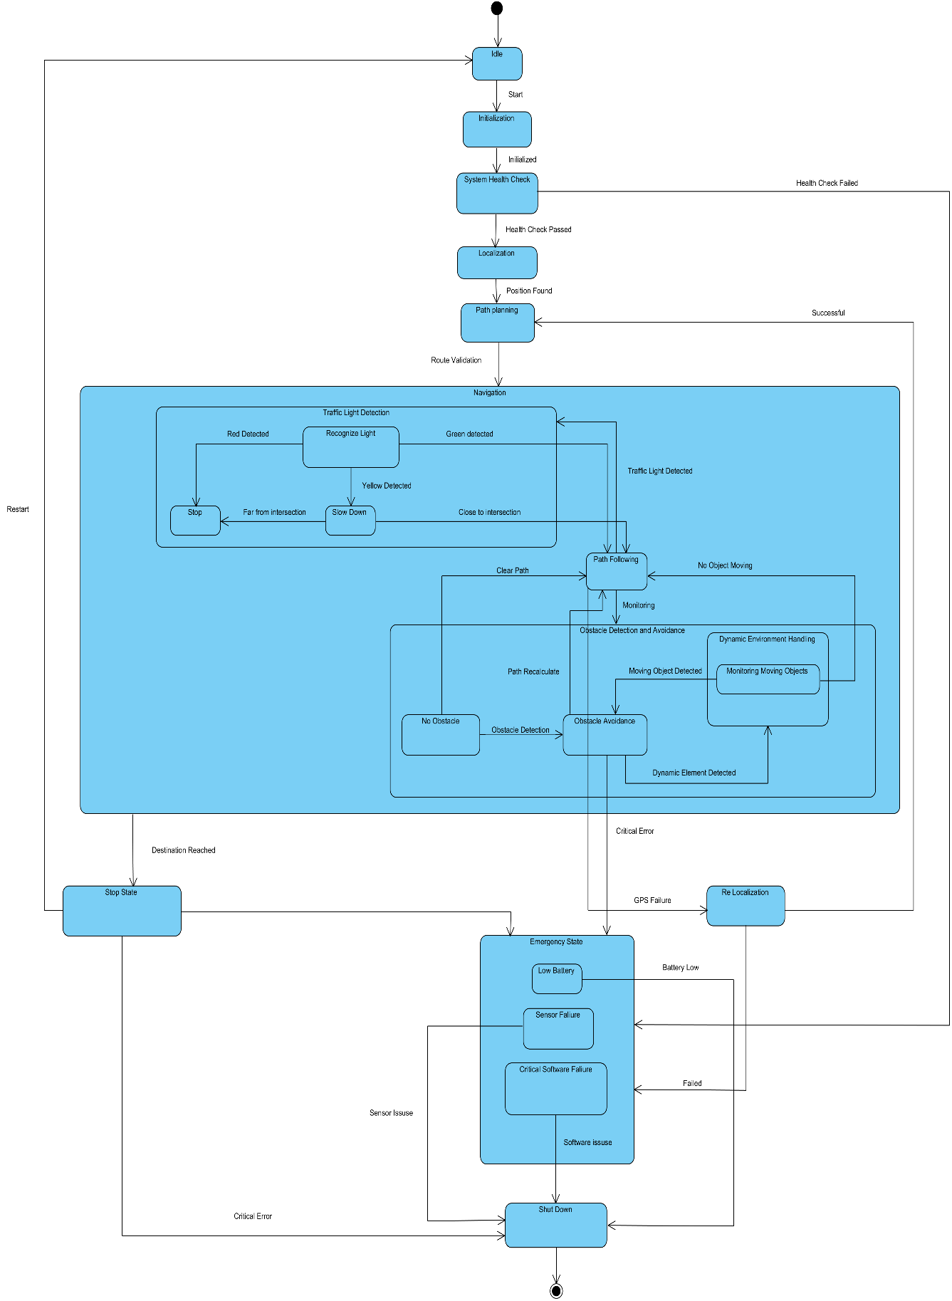

*Figure 4.4: System state chart diagram*

* + - 1. **Path planning state chart diagram**

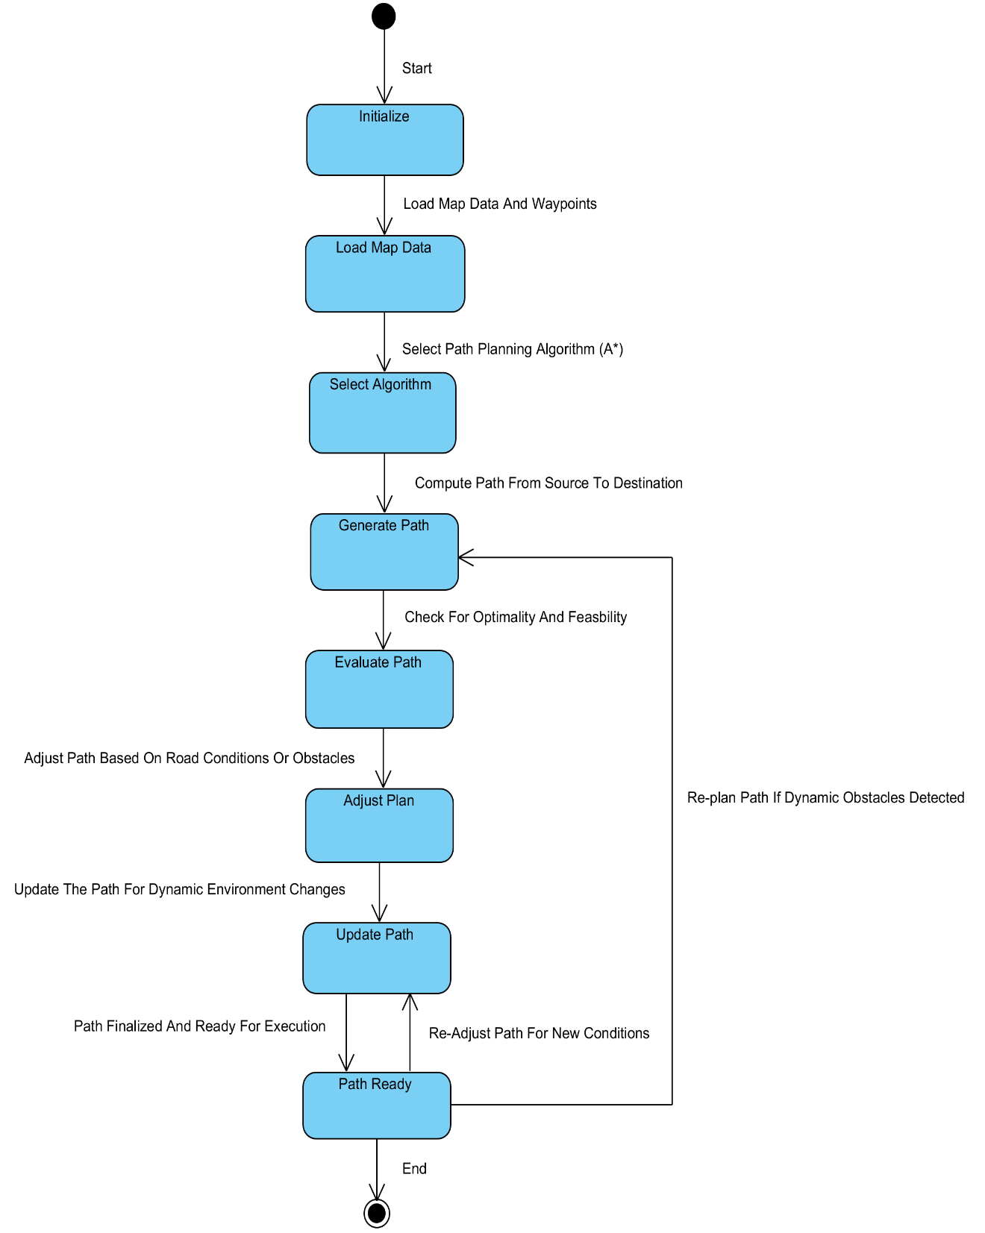

*Figure 4.5: Path Planning State Chart diagram*

* + - 1. 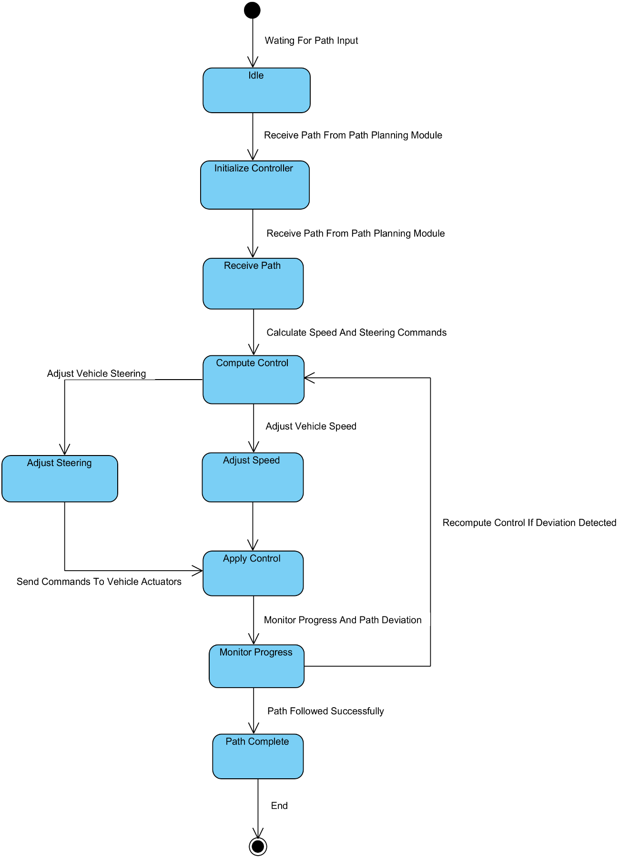**Path following state chart diagram**

*Figure 4.6: Path Following State Chart diagram*

* + - 1. **Vehicle control state chart diagram**

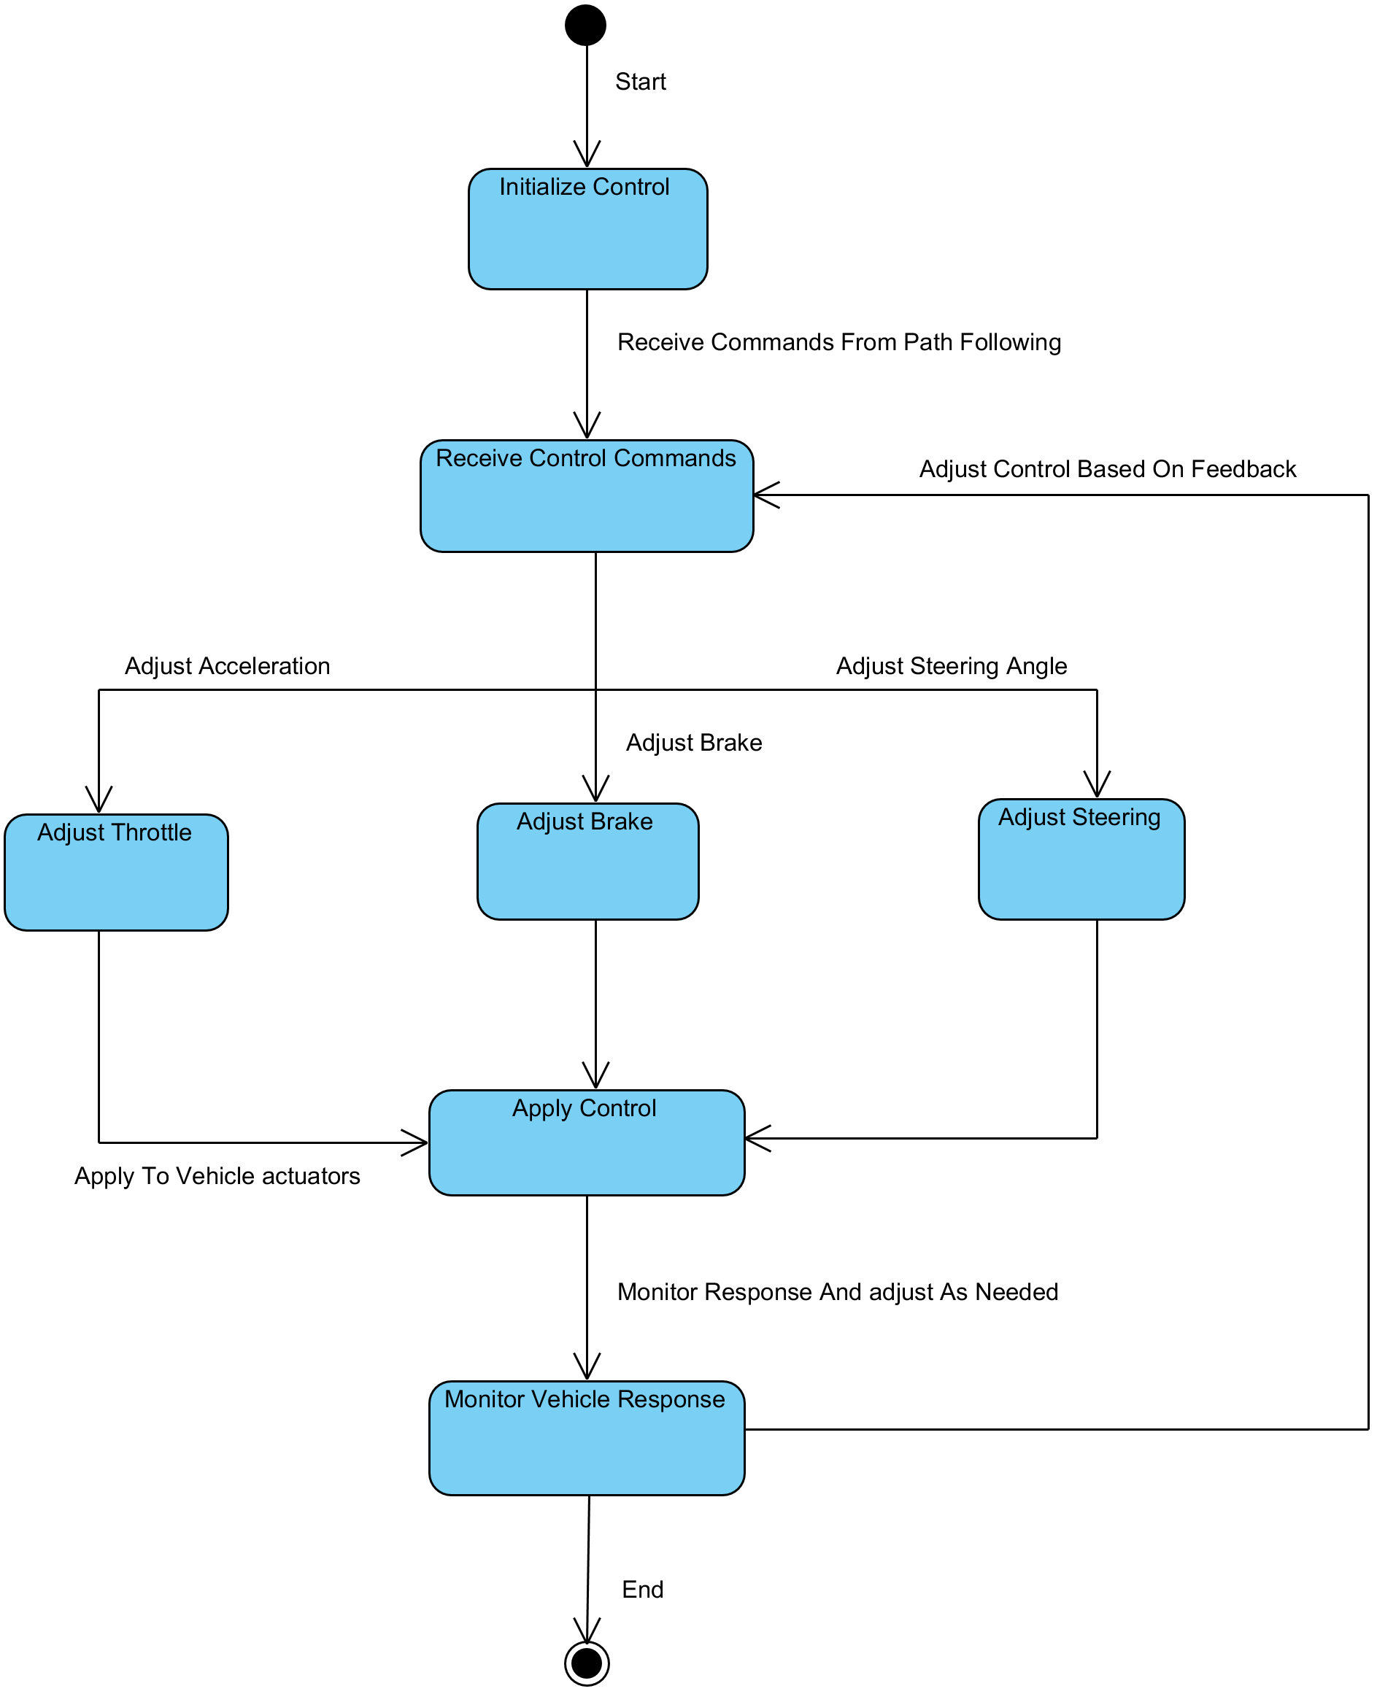

*Figure 4.7: Vehicle Control State Chart diagram*

* + - 1. **Localization state chart diagram**

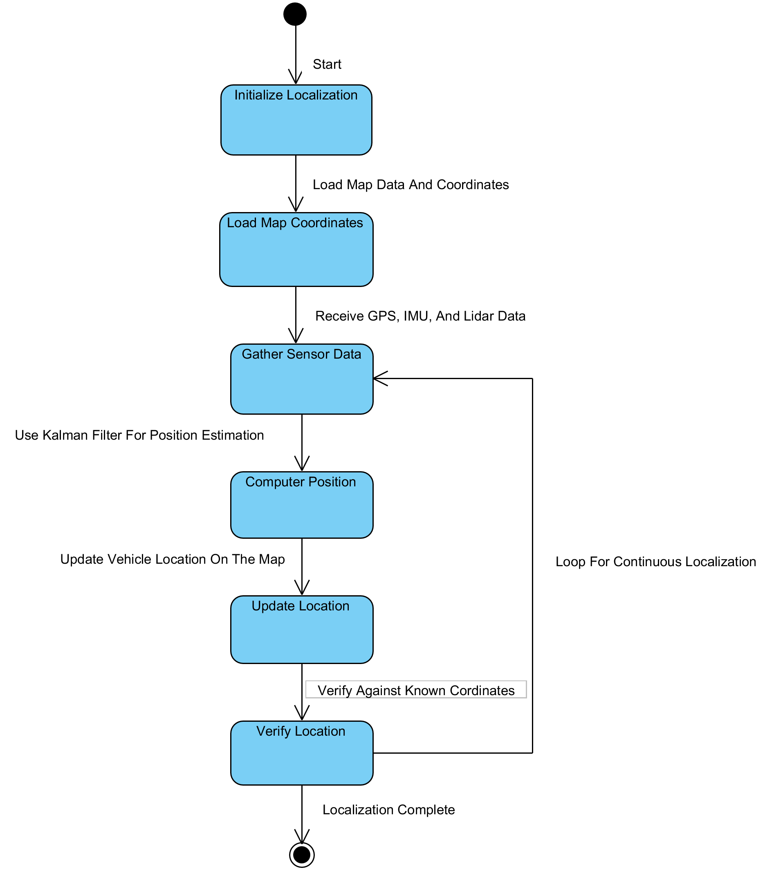

*Figure 4.8: Localization State Chart diagram*

* + - 1. **Perception state chart diagram**

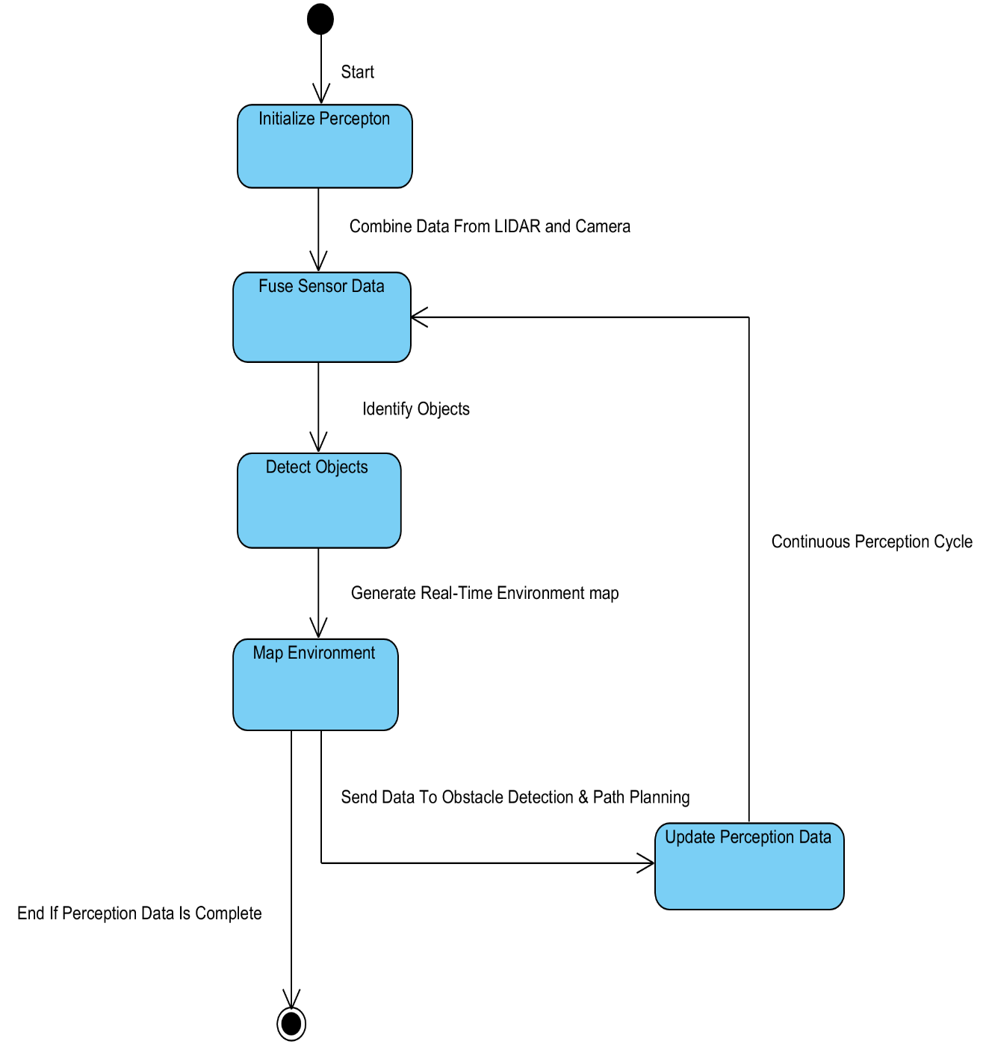

*Figure 4.9: Perception State Chart diagram*

* + - 1. **Obstacle detection and avoidance state chart diagram**

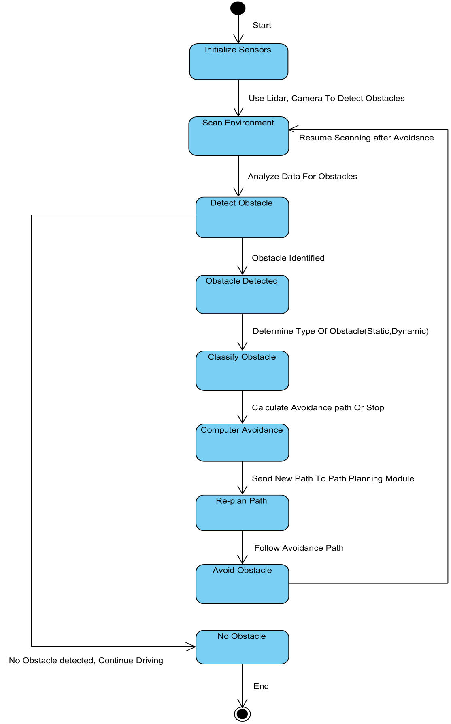

*Figure 4.10: Obstacle Detection and avoidance State Chart diagram*

* + - 1. **Error handling and recovery state chart diagram**

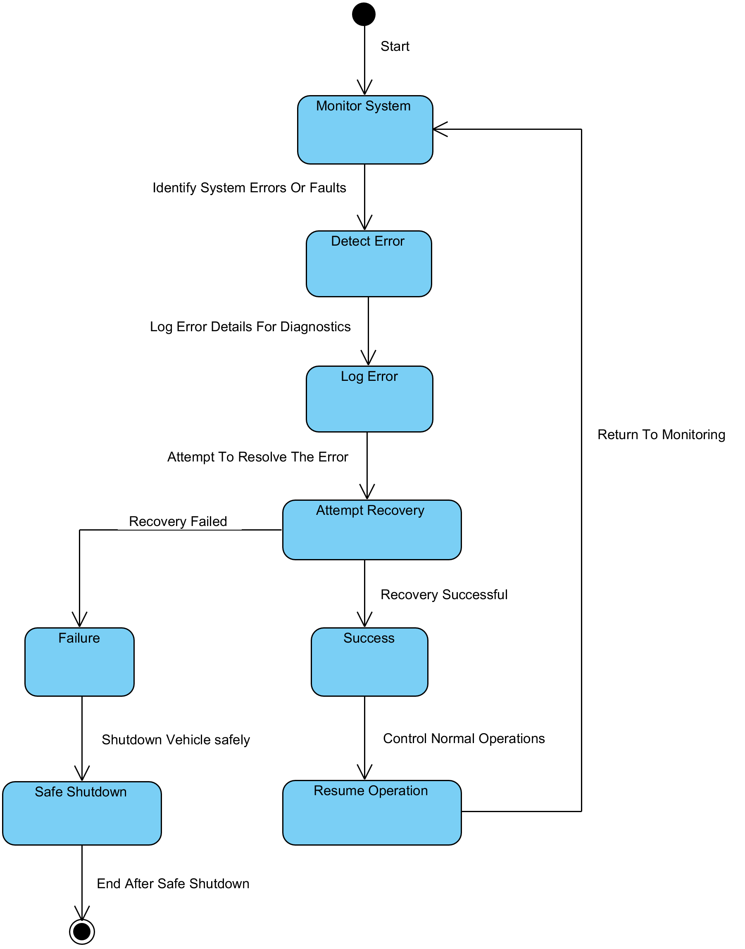

*Figure 4.11: Error Handling and Recovery State Chart diagram*

* + - 1. **Traffic light detection state chart diagram**

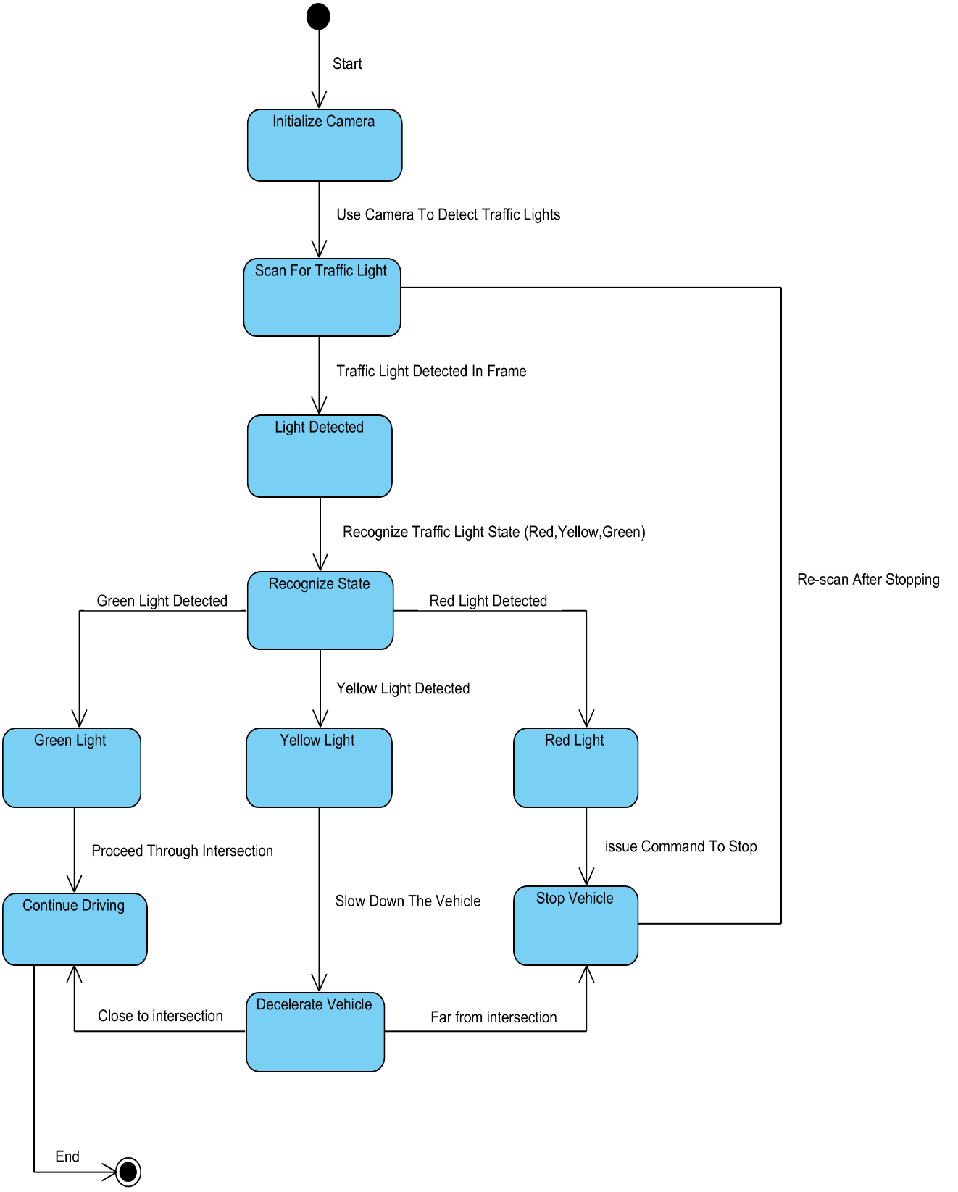

*Figure 4.12: Traffic Light Detection State Chart diagram*

* + - 1. **Simulation integration state chart diagram**

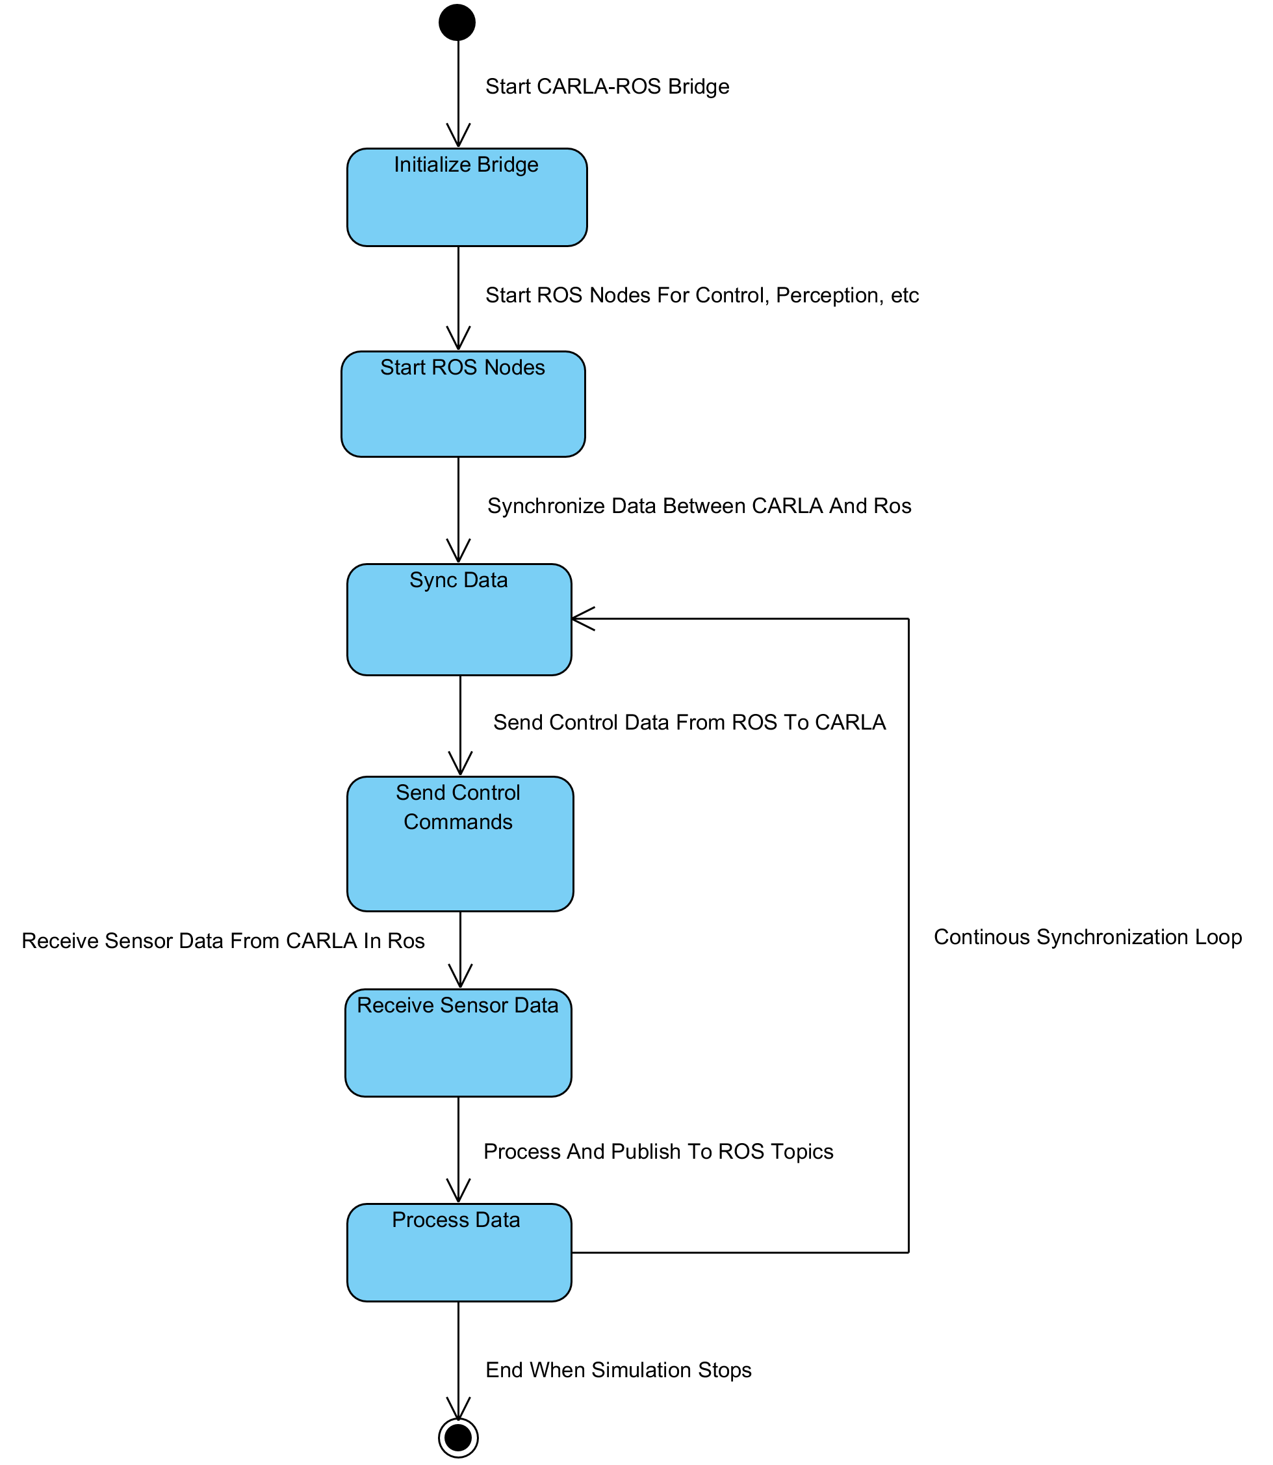

*Figure 4.13: Simulation Integration State Chart diagram*

## SQA activity: State-Based Defect Detection Scenarios

* + 1. **Path Planning**

**Equivalence Class Partitioning (ECP):**

* **Valid Classes**:
* The destination is selected from the provided options.
* The destination is entered manually and is valid (x is integer, y is integer).
* **Invalid Classes**:
* The destination is selected but is not available (e.g., out of service area).
* The destination coordinates are entered manually but are invalid (e.g., incorrect format, non-existent location).

**Scenarios and Test Case:**

*Table 4.1: State-Based TC1*

|  |  |  |  |
| --- | --- | --- | --- |
| **Scenario** | **Input Value** | **ECP** | **Expected Output** |
| Out of service area coordinates | x = 80.000000  y = 170.000000 | Invalid | **Error**: Vehicle tries to go to the entered Coordinates, even if they are in any building |

* + 1. **Path Following**

**Equivalence Class Partitioning (ECP):**

* **Valid Classes**:
  + The vehicle's velocity and acceleration parameters are within normal operational ranges. i.e. <120 km/h
* **Invalid Classes**:
  + The vehicle's velocity or acceleration parameters are abnormal or invalid. i.e. = 120km/h

**Scenarios and** **Test Cases:**

*Table 4.2: State-Based TC2*

|  |  |  |  |
| --- | --- | --- | --- |
| **Test Case** | **Input Value** | **ECP** | **Expected Output** |
| Abnormal Velocity Parameters | Velocity = 200 km/h | Invalid | Unexpected Error |
| Negative Velocity Parameters | Velocity = -20 km/h | Invalid | Unexpected Error |

* + 1. **Vehicle Control**

**Equivalence Class Partitioning (ECP):**

* **Valid Classes:**
  + The vehicle's speed is within the normal operational range (i.e. 0 km/h to maximum speed limit).
  + The throttle position is within the normal operational range (i.e. 0% to 100%).
* **Invalid Classes:**
  + The vehicle's speed parameters are abnormal or invalid (i.e. speed exceeding maximum permissible limit).
  + The throttle position is abnormal or invalid (i.e. throttle position exceeding 100%).

**Scenarios and Test Cases:**

*Table 4.3: State-Based TC3*

|  |  |  |  |
| --- | --- | --- | --- |
| **Test Case** | **Input Value** | **ECP** | **Expected Output** |
| Negative Speed | Speed = -10 km/h | Invalid | Unexpected Error |
| Negative Throttle Position | Throttle = -20% | Invalid | Unexpected Error |

* + 1. **Vehicle Control**

**Equivalence Class Partitioning (ECP):**

* **Valid Classes:**

Normal Steering: Steering angle within operational range

* -90° to 90° latitude, -180° to 180° longitude
* **Invalid Classes:**

Abnormal Steering: Steering angle outside operational range (< -30° or > +30°)

**Scenarios and Test Cases:**

*Table 4.4: State-Based TC4*

|  |  |  |  |
| --- | --- | --- | --- |
| **Test Case** | **Input Value** | **ECP** | **Expected Output** |
| Abnormal Orientation | Roll = -220°  Pitch = of 120° | Invalid | Unexpected Error |
| Abnormal Steering Angle | Range = -45°, 40° | Invalid | Unexpected Error |

* + 1. **Vehicle Control**

**Equivalence Class Partitioning (ECP):**

* **Valid Classes:**
* Speed: 0 km/h ≤ Speed ≤ 120 km/h
* Distance: 2 meters ≤ Distance ≤100 meters
* Throttle Adjustment: 0 % ≤ Throttle ≤ 80 %
* Brake Application: 0 % ≤ Braking Force ≤ 100 %
* **Invalid Classes:**
* Speed: > 120 km/h
* Distance: Distance >100 meters
* Throttle Adjustment: < 0 % or Throttle > 80 %
* Brake Application: < 0 % or Braking Force > 100 %

**Scenarios and Test Cases:**

*Table 4.5: State-Based TC5*

|  |  |  |  |
| --- | --- | --- | --- |
| **Test Case** | **Input Value** | **ECP** | **Expected Output** |
| Abnormal Steering Angle | Range = -45°, 40° | Invalid | Unexpected Error |
| Unsafe distance | Distance = 0 | Invalid | Unexpected Error |
| Braking force | Force = 152% | Invalid | Unexpected Error |
| Abnormal Speed | Speed = -15.2 | Invalid | Unexpected Error |

* + 1. **Vehicle Control**

**Equivalence Class Partitioning (ECP):**

* **Valid Classes:**
* Lateral Position: -1.0 meters ≤ Lateral Position ≤ 1.0 meters
* Steering Adjustment: -30° ≤ Steering Angle ≤30°
* **Invalid Classes:**
* Lateral Position: Lateral Position > 1.0 meters
* Steering Adjustment: Steering Angle > 30°

**Scenarios and Test Cases:**

*Table 4.6: State-Based TC6*

|  |  |  |  |
| --- | --- | --- | --- |
| **Test Case** | **Input Value** | **ECP** | **Expected Output** |
| Abnormal Lateral Position | Lateral Position = -2.0 meters | Invalid | Unexpected Error |
| Excessive Steering Adjustment | Angle = -45.23° | Invalid | Unexpected Error |

* + 1. **Localization Module Test Cases**

**Equivalence Class Partitioning (ECP):**

* **Valid Classes:**
* Sensor data (GPS, IMU, LIDAR) within acceptable ranges.
* GPS accuracy ≤ 5 meters.
* IMU data drift ≤ 2 degrees.
* LIDAR scan range ≥ 50 meters.
* **Invalid Classes:**
* Sensor data outside acceptable ranges.
* GPS accuracy > 5 meters.
* IMU data drift > 2 degrees.
* LIDAR scan range < 50 meters.

**Scenarios and Test Cases:**

*Table 4.7: State-Based TC7*

|  |  |  |  |
| --- | --- | --- | --- |
| **Scenario** | **Input Value** | **ECP** | **Expected Output** |
| GPS Signal Loss | GPS Accuracy = 15 meters | Invalid | Transition to Error State: "Localization Error" |
| GPS Signal Loss | GPS Status = No signal | Invalid | Unexpected Error |
| IMU Drift | IMU Drift = 1.5 degrees | Valid | Transition to Update Location |
| LIDAR Scan Range Too Short | LIDAR Range = 30 meters | Invalid | Transition to Error State: "LIDAR Range Error" |
| Accurate Localization | GPS Accuracy = 3 meters  IMU Drift = 1 degree | Valid | Transition to VerifyLocation |

* + 1. **Obstacle Detection and Avoidance Module Test Cases**

**Equivalence Class Partitioning (ECP):**

* **Valid Classes:**
* Obstacle detected within sensor range.
* LIDAR detection distance ≤ 100 meters.
* Obstacle size ≥ 0.5 meters.
* Obstacle-free zone.
* No objects detected within 100 meters.
* **Invalid Classes:**
* Sensor fails to detect within expected range.
* LIDAR detection distance > 100 meters for a detected obstacle.
* Obstacle size < 0.5 meters considered noise.

**Scenarios and Test Cases:**

*Table 4.8: State-Based TC8*

|  |  |  |  |
| --- | --- | --- | --- |
| **Scenario** | **Input Value** | **ECP** | **Expected Output** |
| No Obstacle Detected | LIDAR Detection Distance = 150 meters | Invalid | Transition to No Obstacle state |
| LIDAR Sensor Failure | LIDAR Status = No data received | Invalid | Unexpected Error |
| Valid Obstacle Detected | LIDAR Detection Distance = 50 meters | Valid | Transition to Classify Obstacle |
| Dynamic Obstacle Within Range | LIDAR Detection Distance = 80 meters | Valid | Transition to Compute Avoidance |

* + 1. **Traffic Light Detection Module Test Cases**

**Equivalence Class Partitioning (ECP):**

* **Valid Classes:**
* Traffic light detected and state correctly identified.
* Distance to traffic light ≤ 50 meters.
* Recognition confidence ≥ 80%.
* **Invalid Classes:**
* Traffic light detection errors or low recognition confidence.
* Distance to traffic light > 50 meters.
* Recognition confidence < 80%.

**Scenarios and Test Cases:**

*Table 4.9: State-Based TC9*

|  |  |  |  |
| --- | --- | --- | --- |
| **Scenario** | **Input Value** | **ECP** | **Expected Output** |
| Traffic Light Not Detected | Detection Distance = 60 meters | Invalid | Continue scanning in ScanForTrafficLight state |
| Traffic Light Detected, High Confidence | Recognition Confidence = 90% | Valid | Transition to Recognize State |
| Camera Failure | Camera Status = No data received | Invalid | Unexpected Error |
| Low Confidence in Recognition | Recognition Confidence = 70% | Invalid | Re-scan for traffic light state |
| Traffic Light at Threshold | Detection Distance = 50 meters | Valid | Proceed with state recognition (Red/Yellow/Green) |

Chapter 5:

**Implementation**

# Chapter 5: Implementation

## Endeavour

In the implementation phase, our team applies rigorous software engineering principles. We plan and execute each task, adhering to industry best practices for reliability. From architectural design to testing, our approach reflects our commitment to delivering high-quality software solutions

* + 1. **Team**
* Bilal Rafiq
* Hamza Azhar
* Sardar Mohsin Saghir
* Muhammad Usama Nazir
  + 1. **Work Breakdown Structure**

1. **Project Management**
   1. Work Breakdown Structure (WBS)
   2. Roles & Responsibility Matrix
   3. Change Control System
   4. Meeting minutes and Progress report
2. **Reports / Documentation**
   1. Team Members and Project Proposal
   2. Project Proposal Document
      1. Opportunity and Stakeholders
      2. Challenges Goals and Objectives
      3. Solution Overview diagram
      4. Report Outline
   3. Literature / Market Survey
      1. Domain Expert Interview Findings
      2. Questionnaire for Technical Feasibility and Risk Assessment
      3. Brainstorming diagram
      4. Academic Research Review
      5. Gap analysis summary
      6. Technology Landscape
         1. SWOT analysis
      7. Questionnaire for Selecting tools and techniques
      8. Specialization - 4 courses series from Coursera
   4. Requirement Analysis
      1. Problem Scenarios
      2. Requirement Elicitation
      3. Questionnaire for gathering requirements
      4. Functional Requirements
      5. Non-Functional Requirement
      6. Inspection Report
      7. Software requirement specification artifact
   5. System Design
      1. Architecture Diagram
      2. Use Case Diagram
      3. Detail Use Cases
      4. Activity Diagrams
      5. System Sequence Diagram
   6. Implementation
      1. Components and Libraries
   7. Testing and Performance Evaluation
      1. Test Scenarios
   8. Conclusion & Outlook
      1. Future Recommendations
   9. Progress Presentation
      1. Slides outlining project progress
      2. Updated Artifacts of part 1
         1. Appendix-A: Software Requirements Specifications (SRS)
         2. Appendix-B: Design Documents
         3. Appendix-C: Coding Standards/Conventions
         4. Appendix-D: Test Scenarios
         5. Appendix-E: Work Breakdown Structure
         6. Appendix-F: Roles & Responsibility Matrix
      3. Answers to potential questions report
   10. Final Presentation part 2
       1. Comprehensive Slides for presentation
       2. Working software system (Complete)
       3. Updated Artifacts (Complete)
          1. Appendix-A: Software Requirements Specifications (SRS)
          2. Appendix-B: Design Documents
          3. Appendix-C: Coding Standards/Conventions
          4. Appendix-D: Test Scenarios
          5. Appendix-E: Work Breakdown Structure
          6. Appendix-F: Roles & Responsibility Matrix
       4. Final Report
3. **System**
   1. Development Environment
      1. IDE
         1. Visual Studio Code
         2. PyCharm
      2. Version Control
         1. Git Hub
      3. Environment Management
         1. Anaconda Distribution
   2. Simulation Environment Setup
      1. CARLA Simulator
         1. Carlaviz for CARLA Visualization
      2. ROS Noetic Configured
      3. CARLA-ROS Bridge Integrated
      4. Vehicle spawn module
      5. Sensor spawn module
      6. Destroy Vehicle module
   3. Path Planning component
      1. Map Reading module
      2. Graph of Roads
      3. Graph of Lanes
      4. List of Driving Lanes within map
      5. Route Calculation module
      6. Algorithm implementation module
      7. Global route planner module
      8. Axis Translation module
      9. Local route planner module
      10. Environment Analysis module
      11. Trajectory Generation module
      12. Junction handling module
   4. Path Following component
      1. Trajectory Tracking module
      2. Basic agent module
      3. Behaviour agent module
      4. Algorithm implementation module
      5. Controller module
      6. Custom Destination module
   5. Vehicle Control component
      1. Throttle Control module
      2. Braking Control module
      3. Acceleration Control module
      4. Steering Control module
      5. Longitudinal Control module
      6. Lateral Control module
      7. Lane changing module
      8. Jerkiness Control algorithm modules
      9. Rotation and Translation module
   6. Sensor Integration module
      1. IMU integration sub-module
      2. GPS integration sub-module
      3. Radar integration sub-module
      4. Lidar integration sub-module
   7. Obstacle Detection
      1. Sensor Fusion module
         1. Lidar-Radar Fusion sub-module
         2. Multi-sensor Data synchronization sub-module
      2. Sensor Data Processing module
      3. Obstacle Detection module
         1. ML based detection sub-module
      4. Distance Estimation module
      5. Object Classification module
   8. Obstacle Avoidance
      1. Dynamic Obstacle handling module
      2. Static Obstacle handling module
      3. Path Adjustment module
         1. Map based planning sub-module
         2. Graph based planning sub-module
      4. Trajectory Estimation module
      5. Maneuver Planning module
         1. Environmental evaluation sub- module
         2. Lane changes sub-module
         3. Decelerate sub-module
         4. Emergency Stop sub-module
      6. Real-time Response module
      7. Tracking module
         1. Kalman filter sub-module
         2. Particle filter sub-module
4. **Open House**
   1. Event Part 1
      1. Standee Design
      2. Printed Standee
      3. Printed Broachers
      4. Pre-recorded Demo video
   2. Event Part 2
      1. Standee Design
      2. Printed Standee
      3. Printed Broachers
      4. Full Working Software
      5. **Roles & Responsibility Matrix:**

*Table 5.1: Responsibilities Assignment Matrix*

|  |  |  |  |  |  |
| --- | --- | --- | --- | --- | --- |
| **WBS#** | **WBS Deliverable** | **Activity #** | **Activity to complete the deliverable** | **Duration (days)** | **Responsible Team Member(s) & Role(s)** |
| 1 | Project Initiation Phase | 1 | Literature Review | 7 | Bilal (A)  Hamza (R)  Mohsin (I)  Usama (R) |
|  |  | 2 | Define project scope and objectives | 5 | Bilal (A/R)  Hamza (C)  Mohsin (C)  Usama (I) |
|  |  | 3 | Establish project team roles and responsibilities | 1 | Bilal (A/R)  Hamza (C)  Mohsin (I)  Usama (I) |
|  |  | 4 | Setup project management tools and communication channels | 1 | Bilal (C)  Hamza (A)  Mohsin (I)  Usama (R) |
| 2 | Requirement Analysis | 5 | Research existing autonomous vehicle technologies and solutions | 3 | Bilal (C)  Hamza (A/R)  Mohsin (I)  Usama (I) |
|  |  | 6 | Gather requirements from stakeholders | 5 | Bilal (A)  Hamza (R)  Mohsin (C)  Usama (C) |
|  |  | 7 | Brainstorming | 2 | Bilal (R)  Hamza (A)  Mohsin (C)  Usama (C) |
|  |  | 8 | Define Problem Scenarios | 1 | Bilal (R)  Hamza (A)  Mohsin (C)  Usama (I) |
|  |  | 9 | Interview Domain Expert | 2 Meetings per week | Bilal (A)  Hamza (R)  Mohsin (I)  Usama (I) |
|  |  | 10 | Define Functional Requirements | 4 | Bilal (R)  Hamza (A)  Mohsin (C)  Usama (I) |
|  |  | 11 | Specify Non-Functional Requirement | 1 | Bilal (A/R)  Hamza (C)  Mohsin (I)  Usama (I) |
|  |  | 12 | System Overview | 2 | Bilal (C)  Hamza (R)  Mohsin (I)  Usama (A) |
|  |  | 13 | Constraints | 1 | Bilal (A/R)  Hamza (C)  Mohsin (I)  Usama (I) |
| 3 | System Design | 14 | Develop Architecture Diagram | 1 | Bilal (C)  Hamza (A/R)  Mohsin (I)  Usama (C) |
|  |  | 15 | Create Use Case Diagram | 1 | Bilal (C)  Hamza (A/R)  Mohsin (R)  Usama (I) |
|  |  | 16 | Define Detail Use Cases | 3 | Bilal (A) Hamza (R) Mohsin (I)  Usama (C) |
|  |  | 17 | Design Activity Diagrams | 3 | Bilal (C) Hamza (I)  Mohsin (A/R)  Usama (I) |
|  |  | 18 | Construct System Sequence Diagram | 1 | Bilal (C)  Hamza (A)  Mohsin (R)  Usama (I) |
| 4 | Simulation Environment Setup | 19 | Install and configure CARLA simulator, ROS Noetic and environment | 8 | Bilal (A)  Hamza (C)  Mohsin (I)  Usama (R) |
|  |  | 20 | Develop scripts for setting up simulation scenarios | 7 | Bilal (A/R)  Hamza (C)  Mohsin (I)  Usama (I) |
|  |  | 21 | Verify integration between CARLA and ROS | 1 | Bilal (A)  Hamza (R)  Mohsin (I)  Usama (I) |
| 5 | Path Planning Algorithm Development | 22 | Defining algorithms for path planning considering dynamic obstacles | 3 | Bilal (A/R)  Hamza (C)  Mohsin (C)  Usama (I) |
|  |  | 23 | Path planning logic in Python using ROS | 20 | Bilal (A)  Hamza (R)  Mohsin (I)  Usama (C) |
|  |  | 24 | Route Calculation | 5 | Bilal (C)  Hamza (A)  Mohsin (I)  Usama (R) |
|  |  | 25 | Map Processing | 1 | Bilal (A)  Hamza (I)  Mohsin (C)  Usama (R) |
|  |  | 26 | Environment Analysis | 2 | Bilal (A)  Hamza (R)  Mohsin (I)  Usama (C) |
|  |  | 27 | Trajectory Generation | 4 | Bilal (C)  Hamza (I)  Mohsin (R)  Usama (A) |
|  |  | 28 | Calculating Waypoints | 2 | Bilal (A)  Hamza (C)  Mohsin (I)  Usama (R) |
|  |  | 29 | Test path planning algorithms in simulated environments | 3 | Bilal (A)  Hamza (R)  Mohsin (I)  Usama (C) |
| 6 | Path Following Implementation | 30 | Defining control algorithms for vehicle control | 2 | Bilal (A/R)  Hamza (R)  Mohsin (I)  Usama (C) |
|  |  | 31 | Integrate path following logic/algorithm | 7 | Bilal (R)  Hamza (A)  Mohsin (C)  Usama (I) |
|  |  | 32 | Trajectory Tracking | 2 | Bilal (A)  Hamza (R)  Mohsin (C)  Usama (I) |
|  |  | 33 | Velocity Control | 3 | Bilal (A)  Hamza (C)  Mohsin (I)  Usama (R) |
|  |  | 34 | Steering Control | 5 | Bilal (C)  Hamza (A)  Mohsin (I)  Usama (R) |
|  |  | 35 | Conduct testing and validation in simulated environments | 5 | Bilal (C)  Hamza (R)  Mohsin (I)  Usama (A) |
| 7 | Obstacle Detection | 36 | Defining strategies for detecting obstacles | 3 | Bilal (C)  Hamza (I)  Mohsin (A/R)  Usama (I) |
|  |  | 37 | Sensor Data Processing | 5 | Bilal (C)  Hamza (I)  Mohsin (A/R)  Usama (I) |
|  |  | 38 | Obstacle Detection | 7 | Bilal (A)  Hamza (C)  Mohsin (R)  Usama (I) |
|  |  | 39 | Distance Estimation | 5 | Bilal (C)  Hamza (A)  Mohsin (R)  Usama (I) |
| 8 | Obstacle Avoidance | 40 | Defining avoidance Maneuver | 1 | Bilal (C)  Hamza (A)  Mohsin (R)  Usama (I) |
|  |  | 41 | Implement obstacle avoidance strategies | 25 | Bilal (C)  Hamza (R)  Mohsin (A)  Usama (I) |
|  |  | 42 | Path Adjustment | 10 | Bilal (C)  Hamza (A)  Mohsin (R)  Usama (I) |
|  |  | 43 | Maneuver Planning | 5 | Bilal (C)  Hamza (I)  Mohsin (A)  Usama (R) |
|  |  | 44 | Real Time Responding | 5 | Bilal (I)  Hamza (C)  Mohsin (A/R)  Usama (C) |
|  |  | 45 | Integrate obstacle detection and avoidance with overall system | 5 | Bilal (C)  Hamza (I)  Mohsin (R)  Usama (A/R) |
| 8 | Sensor Integration and Calibration | 46 | Integrate sensors with the autonomous vehicle in simulation | 2 | Bilal (A)  Hamza (C)  Mohsin (I)  Usama (R) |
|  |  | 47 | Calibrate sensor data for accurate perception | 6 | Bilal (A)  Hamza (C)  Mohsin (R)  Usama (I) |
|  |  | 48 | Validate sensor data in simulated and real-world scenarios | 7 | Bilal (C)  Hamza (A/R)  Mohsin (R)  Usama (I) |
| 9 | System Integration | 49 | Integrate all software components into the autonomous vehicle system | 5 | Bilal (I)  Hamza (R)  Mohsin (C)  Usama (A/R) |
| 10 | Simulated Testing | 50 | Conduct comprehensive testing | 6 | Bilal (I)  Hamza (A/R)  Mohsin (C)  Usama (R) |
|  |  | 51 | Iterate on software development based on testing feedback | 2 | Bilal (R)  Hamza (I)  Mohsin (A)  Usama (C) |
|  |  | 52 | Fine-tune algorithms and software based on testing results | 3 | Bilal (C)  Hamza (A/R)  Mohsin (R)  Usama (I) |
| 11 | Optimization and Finalization | 53 | Optimize software performance and efficiency | 2 | Bilal (C)  Hamza (R)  Mohsin (A)  Usama (I) |
|  |  | 54 | Address any remaining issues or bugs | 1 | Bilal (I)  Hamza (C)  Mohsin (R)  Usama (A/R) |
|  |  | 55 | Finalize the project documentation and deliverables | 2 | Bilal (A/R)  Hamza (C)  Mohsin (C)  Usama (C) |

## Proposed Solution

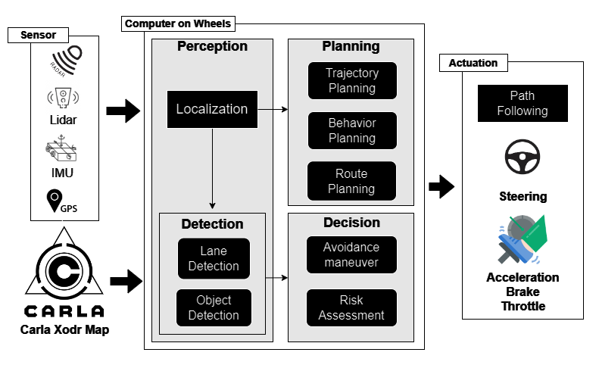Our solution aims to enable autonomous vehicles to navigate by integrating advanced path planning, obstacle detection, and precise vehicle control. The following diagram outlines the proposed solution of our system.

*Figure 5.1: Proposed Solution*

## Components and Libraries

**5.3.1 Components:**

|  |  |
| --- | --- |
| * Map Parser | * Obstacle Avoider |
| * Traffic Generator | * Localization Module |
| * Path Planner | * Sensor Data Fusion |
| * Trajectory Follower | * Control System |
| * Behaviour Planner | * Decision-Making Module |
| * Environment Perception | * Simulation Environment |
| * Obstacle Detector | * ROS Noetic Framework |
| * CARLA-ROS Bridge | * Traffic Light Detection |

**5.3.2 Libraries:**

|  |  |
| --- | --- |
| * rospy | * weakref |
| * NumPy | * pygame |
| * math | * carla |
| * xmltodict | * collections.deque |
| * argparse | * networkx as nx |
| * collections | * carla_msgs |
| * datetime | * sensor_msgs |
| * logging | * OpenCV |
| * Matplotlib | * TensorFlow |
| * Cv2 | * tf (ROS Transform Library) |

## IDE, Tools, Technologies and Development Platform

* + 1. **IDEs**
* PyCharm
* Visual Studio Code
  + 1. **Development Platform:**
* Ubuntu
* ROS (Robot Operating System)
  + 1. **Tools**
* GitHub
* Jira
* Microsoft office
* Visual Paradigm
* OpenDRIVE viewer
* Carlaviz
* Anaconda
  + 1. **Technologies**
* Carla Simulator
* Carla-Ros-Bridge
* ROS Noetic
* Rospy
* Robot_localization
* Python

## Best Practices / Coding Standards

* + 1. **Software Engineering Practice: Waterfall Model**

In our project, we adopted the Waterfall model to ensure a structured and disciplined approach to software engineering, aligning with the linear nature of embedded software development for autonomous vehicles. The Waterfall methodology allowed us to maintain clear requirements, detailed design, rigorous testing, and documentation throughout the project lifecycle. This approach ensured a reliable and maintainable software system, well-suited to the specific needs of autonomous vehicle applications.

* + 1. **Waterfall Model Phases**

We structured our project using the traditional Waterfall model, progressing sequentially through each phase with distinct deliverables and checkpoints. Key phases included:

* **Requirements Gathering and Analysis**: We began with a comprehensive requirements analysis, defining the system's functional and non-functional requirements based on the unique needs of autonomous navigation in a personal use context. This phase involved consultation with domain experts and thorough documentation review to ensure the project's objectives were clearly defined from the start.
* **System Design**: In the design phase, we translated our requirements into a detailed system architecture, encompassing each module’s functionality and interaction. Our design also involved defining the software architecture, sensor layout, control algorithms, and data communication protocols. Detailed design documentation provided a blueprint for the subsequent implementation phase, ensuring a structured approach to development.
* **Implementation**: With a finalized design, we proceeded to code each component in adherence to the Waterfall model's strict guidelines. This phase involved the systematic development of individual modules, such as the path planning, obstacle detection, and control modules. Emphasis was placed on producing clean, well-documented code aligned with the project's requirements and design specifications.
* **Integration and Testing**: Following implementation, we conducted rigorous testing to validate each module's functionality and ensure seamless integration. Unit testing, integration testing, and system testing were performed in a systematic manner to validate the accuracy, reliability, and safety of the embedded system. Particular attention was given to testing scenarios that replicated real-world challenges, such as adverse weather conditions, obstacle detection, and traffic light recognition.
* **Deployment and Maintenance Planning**: After successful testing, the system was prepared for deployment. Although the Waterfall model is generally less iterative, we planned for periodic maintenance activities to address any future updates, bug fixes, or additional requirements. Comprehensive documentation was created to support future maintenance and ensure long-term system sustainability.
  + 1. **Documentation and Review Process**

In adherence to the Waterfall model’s emphasis on thorough documentation, each phase of the project was accompanied by detailed documentation and reviews:

* **Phase Sign-Offs**: Each phase required a formal sign-off from the project supervisor, ensuring that all objectives were met before proceeding to the next phase. This structure minimized the risk of scope creep and ensured that every phase met quality standards before progressing.
* **Detailed Documentation**: Every requirement, design decision, and test case were documented meticulously to provide a clear reference for future maintenance and updates. This ensured that the system could be reliably extended or updated as needed.
  + 1. **Python coding Standards**
* Use snake_case for variable and function names.
* Use CamelCase for class names.
* Follow PEP 8 guidelines for code formatting.
* Use meaningful variable and function names.
* Keep lines of code within 79 characters.
* Use comments to explain complex parts of the code.
* Use docstrings to document modules, classes, and functions.
* Avoid using global variables unless necessary.
* Handle exceptions gracefully.
* Use virtual environments to manage dependencies.
  + 1. **Rospy coding Standards**
* Follow Python coding standards for rospy code.
* Use rospy naming conventions for nodes, topics, and services.
* Utilize rospy log functions for logging messages.
* Ensure ROS dependencies are properly declared in package.xml and CMakeLists.txt.
* Document ROS nodes, topics, and services using ROS comments.
* Use rospy's rospy.spin() to keep the node alive.
* Handle ROS messages and services according to their specifications.
* Use rospy's parameter server for managing node parameters.
* Implement proper error handling for ROS communication.

## Deployment Environment

A local server hosts the CARLA simulator and the autonomous vehicle software system, facilitating communication via the CARLA-ROS bridge.

* + 1. **Deployment Diagram**

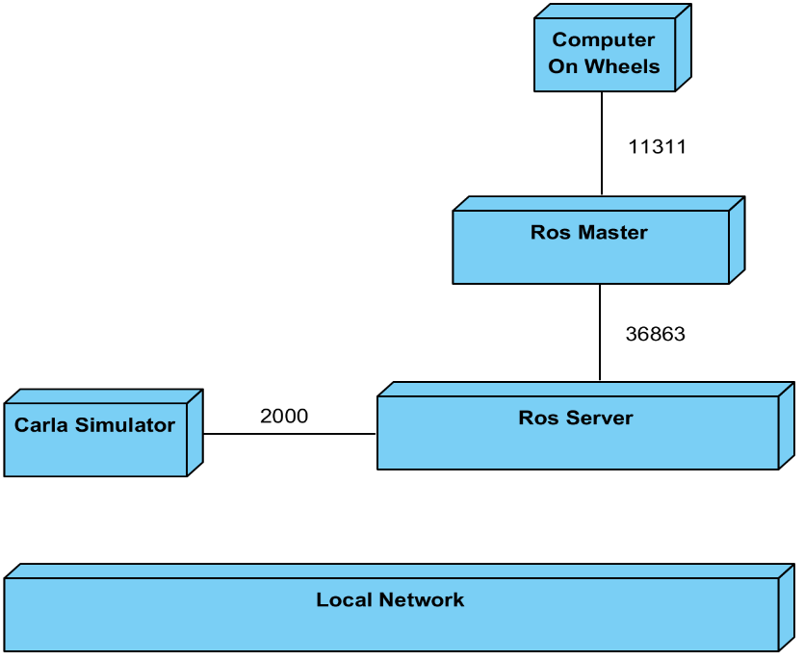

*Figure 5.5: Deployment diagram*

## SQA activity: Defect Detection Through White Box Testing

* + 1. **Test Cases: Dijkstra vs A* with Obstacle on Path**

The following test cases highlight the different behaviours of Dijkstra and A* algorithms when faced with obstacles in path planning scenarios. Dijkstra fails because of significant performance degradation due to frequent re-routing around obstacles, whereas A* demonstrates resilience by dynamically adjusting its route based on heuristic information, thereby providing reliable navigation solutions for autonomous systems.

**Equivalence Class Partitioning (ECP) for start_node and end_node**

* Valid Classes
* start_node and end_node are valid integers within the grid bounds.
* xstart, xend ∈ Z
* ystart, yend ∈ Z
* Invalid Classes
* start_node or end_node as non-integer values or out of grid bounds.
* xstart, xend, ystart, yend ∉ Z

*Table 5.2: White Box TC1*

|  |  |  |  |  |  |  |
| --- | --- | --- | --- | --- | --- | --- |
|  |  | **Input Variables** | |  |  |  |
| **Test ID** | **Algorithm** | **start_node** | **end_node** | **ECP** | **Actual Output** | **Error/Defect** |
| TC001 | Dijkstra | (1,1) | (5,5) | Valid | Error: "Path blocked by obstacle" | Significant performance degradation due to frequent re-routing around obstacles |
| TC002 | A* | (1,1) | (5,5) | Valid | List of node ids (int) connecting origin and destination, avoiding the obstacle. | None |

* + 1. **Endless erratic behavior Around Destination**

These test cases focus on the behaviour of the vehicle when it receives the same destination coordinates but its already there, in such case the vehicle starts behaving erratically

**Equivalence Class Partitioning (ECP) for x and y**

* Valid Classes
* X and Y are valid integers within the grid bounds.
* x∈ Z
* y∈ Z
* Invalid Classes
* X or Y as non-integer values or out of grid bounds.
* X, Y∉ Z

*Table 5.3: White Box TC2*

|  |  |
| --- | --- |
| **Input Variables** | |
| **Test ID** | **x** | **y** | **ECP** | **Actual Output** | **Error/Defect** |
| TC003 | -100.00 | 40.00 | Valid | Vehicle moves to the location (-100.00, -40.00) | None |
| TC004 | -100.00 | 40.00 | Valid | Error: "Stuck in endless loop around the location (-100.00, -40.00)" | Erratic behaviour of car Around Destination |

* + 1. **System Shuts Down After Reaching First Destination**

This test case focus on the behaviour of the system when vehicle reaches a destination and the system shuts down instead of taking the next destination.

*Table 5.4: White Box TC3*

|  |  |
| --- | --- |
| **Input Variables** | |
| **Test ID** | **x** | **y** | **ECP** | **Actual Output** | **Error/Defect** |
| TC005 | -100.00 | 40.00 | Valid | System shuts down after reaching destination  (-100.00, -40.00) | System does not take next destination, shuts down |

* + 1. **System Crashes Due to Invalid Input Types for Coordinates**

These test cases focus on invalid input types for coordinateswhich results in crashing/shutting down the system.

*Table 5.5: White Box TC4*

|  |  |
| --- | --- |
| **Input Variables** | |
| **Test ID** | **x** | **y** | **ECP** | **Actual Output** | **Error/Defect** |
| TC006 | "abc" | "def" | Invalid | Error | System crashes when given string inputs |
| TC007 | "@#$" | "%^&" | Invalid | Error | System crashes when given special characters |

* + 1. **Spawn Point for Vehicle**

These test cases focus on validating the error handling of the system when given invalid input variables for spawn points, including None values, excessively large coordinates, and non-integer inputs.

|  |  |
| --- | --- |
| **Input Variables** | |
| **Test ID** | **x** | **y** | **ECP** | **Actual Output** | **Error/Defect** |
| TC008 | None | -133.808 | Invalid | Error | Spawn point with None x coordinate causes failure |
| TC009 | -2.0230992692528655 | None | Invalid | Error | Spawn point with None y coordinate causes failure |
| TC010 | -2.0230992692528655 | -133.808 | Invalid | Error | Invalid actor type causes service call failure |
| TC011 | 999999999999999999 | 999999999999999999 | Invalid | Error | Large positive x,y coordinate causes service call failure |
| TC012 | “ ” | sdsd | Invalid | Error | Empty or non-integer causes failure |

*Table 5.6: White Box TC5*

* + 1. **Steering Control**

These test cases focus on validating the robot's behavior is either as expected under these conditions or not.

**Equivalence Class Partitioning (ECP) for target_linear_speed and target_angular_speed**

* Valid Classes
* Positive integers only
* Invalid Classes
* Negative Integers
* None
* String

*Table 5.7: White Box TC6*

|  |  |
| --- | --- |
| **Input Variables** | |
| **Test ID** | **target_linear_speed** | **target_angular_speed** | **ECP** | **Actual Output** | **Error/Defect** |
| TC013 | -1.0 | 0.0 | Invalid | Robot moves backward | Negative linear speed does not stop robot moving backward |
| TC014 | 0.5 | None | Invalid | Robot turns in unpredictable motion | Missing angular speed does led to unpredictable turns |

* + 1. **previous_destination is not initialized or updated correctly**

**Equivalence Class Partitioning (ECP) for previous_destination**

* Valid Classes
* ∈ Z
* Invalid Classes
* ∉ Z
* Empty

*Table 5.8: White Box TC7*

|  |
| --- |
| **Input Variables** |
| **Test ID** | previous_destination | **ECP** | **Actual Output** | **Error/Defect** |
| TC015 | None | Invalid | Error | System crash |

* + 1. **Jerkiness**

|  |  |
| --- | --- |
| **Input Variables** | |
| **Test ID** | **x** | **y** | **ECP** | **Actual Output** | **Error/Defect** |
| TC016 | -150.0 | 45.0 | Valid | Jerkiness (Sudden Movements) especially on curves | Vehicle exhibits significant jerky motion on tight curves |

This test case focuses on observing the vehicle's behavior for jerkiness and sudden movements on tight curves.

*Table 5.9: White Box TC8*

* + 1. **PID Controllers to perform longitudinal control**

**Equivalence Class Partitioning (ECP) for target_speed and waypoint**

* Valid Classes
* target_speed > 0
* waypoint ∈ Z
* Invalid Classes
* target_speed <= 0
* waypoint ∉ Z

*Table 5.10: White Box TC9.1*

|  |
| --- |
| **Input Variables** |
| **Test ID** | target_speed | **ECP** | **Actual Output** | **Error/Defect** |
| TC017 | 0 | Invalid | Vehicle oscillates/does not stop | Improper handling of zero target speed |

|  |
| --- |
| **Input Variables** |
| **Test ID** | waypoint | **ECP** | **Actual Output** | **Error/Defect** |
| TC018 | None | Invalid | Vehicle does not steer or crashes randomly | None waypoint not handled properly |

*Table 5.11: White Box TC9.2*

* + 1. **Ackermann Steering Model**

This test case focuses on testing for ZeroDivisionError when calculating the turning radius with a zero inner wheel angle.

**Equivalence Class Partitioning (ECP) for wheel_base and inner_wheel_angle ∈ R**

* Valid Classes
* wheel_base > 0
* inner_wheel_angle ∈ R
* Invalid Classes

|  |  |
| --- | --- |
| **Input Variables** | |
| **Test ID** | **wheel_base** | **inner_wheel_angle** | **ECP** | **Actual Output** | **Error/Defect** |
| TC019 | -2 | 0.5 | Invalid | ZeroDivisionError | Given inner_wheel_angle = 0, the calculation for the turning radius results in a division by zero. This will cause the program to raise a ZeroDivisionError. Therefore, the actual output in this case is an error rather than a valid pair of steering angles. |

* wheel_base ≤ 0, inner_wheel_angle: ∅

*Table 5.12: White Box TC10*

* + 1. **Spawning the vehicle**

This test case focuses on verifying the system's behavior when given a valid vehicle name, ensuring that the success flag accurately reflects whether the vehicle was actually spawned.

**Equivalence Class Partitioning (ECP) for** **vehicle_name**

* Valid Classes
* vehicle_name: String
* Invalid Classes
* vehicle_name: None

|  |
| --- |
| **Input Variables** |
| **Test ID** | vehicle_name | **ECP** | **Actual Output** | **Error/Defect** |
| TC020 | Car1 | Valid | True | The success flag is always set to True without verifying if the vehicle was actually spawned. |

*Table 5.13: White Box TC11*

## Summary

In this chapter we have provided a list of components and libraries that we have used in our project for better user experience. We have mentioned Work breakdown structure WBS and Control flow diagram. We have also mentioned tools and IDEs and best practices and coding standards of software engineering.

**Chapter 6:**

**Conclusion and Outlook**

# Chapter 6: Conclusion and Outlook

## Introduction

This chapter concludes the development of an embedded software system for autonomous navigation within a simulated personal vehicle environment. The system was designed to ensure safe and efficient travel from a designated source to a destination, focusing on path planning, obstacle detection, and traffic light response. The following sections outline the specific achievements, challenges, and recommendations for enhancing the system's embedded software capabilities in future implementations.

## Achievements and Improvements

The embedded software system accomplished its core objectives, successfully implementing key navigation features crucial for autonomous personal vehicles. Key achievements include:

* + 1. **Integration of Embedded Software Technologies**: The system seamlessly integrated CARLA for vehicle simulation, ROS Noetic for robotic operation, and the CARLA-ROS bridge for communication between the two. This combination provided a platform that mimicked real-world scenarios, allowing a detailed assessment of the system’s embedded capabilities.
    2. **Functional Software Modules in a personal** **Vehicle Context**: The software includes specialized modules for critical navigation tasks tailored to personal vehicle requirements, including Path Planning, Path Following, Obstacle Detection and Avoidance, and Traffic Light Recognition. These modules were specifically configured to prioritize personal safety, reliable state transitions, and responsive control, fundamental to any embedded system in a personal vehicle.
    3. **Simulation Testing for Real-Time Responsiveness**: Extensive testing in CARLA allowed the system to demonstrate real-time response in critical situations, such as rapid deceleration for obstacles or timely stopping at traffic lights. The simulator provided a controlled environment to refine the software’s timing constraints and real-time control functions, essential features for embedded systems in automotive safety.
    4. **Optimized Code for Embedded System Constraints**: To align with typical embedded system requirements, the software was designed with efficient code and resource management in mind. Optimizations in the path-following and obstacle avoidance algorithms reduced processing demands, a significant accomplishment given the limited computational resources common in embedded systems.

## Critical Review

While the embedded software system achieved its primary goals, several challenges were encountered:

* + 1. **Limitations of Simulation-Only Testing**: While CARLA’s simulation is robust, the exclusive reliance on software simulation introduced limitations in verifying hardware performance. Embedded systems in personal vehicles often require hardware testing to validate real-time performance, response to environmental factors, and sensor accuracy—areas not fully replicated in simulation.
    2. **High GPU Usage and Computational Demands**: The system’s heavy reliance on GPU resources, especially during intensive simulation tasks, posed a challenge. For an embedded software system, particularly in automotive applications, high GPU dependency is impractical, as most onboard computing units prioritize low-power, efficient processing. Optimizing the software for lower GPU requirements or identifying alternatives to GPU-heavy processes would be crucial for a viable real-world deployment.
    3. **Traffic Light Detection Limitations Without AI**: The traffic light module relied on rule-based methods rather than machine learning, restricting its adaptability. An embedded personal vehicle system may benefit from machine learning models that provide more accurate and context-aware recognition, especially in varied or ambiguous lighting conditions.

## Future Recommendations/Outlook

Future advancements can build on this embedded software system by addressing its current limitations and expanding its capabilities for real-world application. Recommendations include:

* + 1. **Transition to Real-World Hardware Testing**: Integrating physical hardware components (such as LIDAR, cameras, and sensors) into the testing process would be invaluable for refining the system’s embedded software behavior under real-world conditions. This step would help verify the system’s robustness and validate its real-time performance, essential in an embedded software context for personal vehicles.
    2. **Machine Learning Integration for Enhanced Detection**: Implementing machine learning in the traffic light and obstacle detection modules could improve accuracy and adaptability, essential for handling complex, dynamic environments in personal vehicles. Machine learning models can provide more reliable context awareness, which is critical for personal safety in real-time embedded systems.
    3. **Optimization for Memory Efficiency and Real-Time Performance**: Improving the system’s handling of high-volume data streams would enhance memory efficiency and overall real-time performance, making it more suitable for the constraints of embedded automotive systems. Future iterations could focus on data compression techniques, efficient data storage, and optimized sensor fusion strategies to maintain responsiveness within strict memory limits.
    4. **Scalability and Extended Scenario Testing**: To prepare for broader deployment, the system can be further optimized for scalability. Enhanced scenario testing with larger and more complex datasets would allow verification of system stability across varied conditions, an important factor in embedded systems for personal safety.

## Summary

In conclusion, this project successfully developed an embedded software system tailored for autonomous navigation in a personal vehicle context. Through extensive testing, the system demonstrated reliable path planning, obstacle detection, and traffic light recognition, all critical features for autonomous operation. The system’s simulation-based approach provided a foundation for real-time responsiveness, while code optimizations supported the resource efficiency required for embedded applications. Though challenges remain, particularly in real-world testing and adaptability, this project lays the groundwork for further advancements. By incorporating hardware validation, machine learning, and advanced memory management, future work can refine this embedded software system, advancing its potential for autonomous personal vehicles.

# References and Bibliography

[1] SAE International. (2023). SAE Standards News: J3016 automated-driving. Retrieved from <https://www.sae.org/blog/sae-j3016-update>

[2] Nilsson, N. J., & Kanal, L. N. (1969). A generalization of the A* algorithm. AI Memo 84, Stanford University.

[3] Ackermann, R. A. (1906). Die Wissenschaftliche Lenkung des Motors [The Scientific Steering of the Motor]. Zweite Mitteilung. S. Hirzel Verlag, Leipzig.

[4] Lee, D. T., & Schachter, B. J. (1980). Two algorithms for constructing a Delaunay triangulation. International Journal of Computer & Information Sciences, 9(3), 219-242.

[5] ROS-bridge. (2023). CARLA Simulator Documentation. Retrieved from https://carla.readthedocs.io/projects/ros-bridge/en/latest/

[6] CARLA Team. (2021). Integrating CARLA with ROS: A practical guide. CARLA Simulator White Paper.

[7] LaValle, S. M. (2006). Planning Algorithms. Cambridge University Press.

[8] Dolgov, D., Thrun, S., Montemerlo, M., & Diebel, J. (2010). Practical search techniques in path planning for autonomous driving. Robotics and Autonomous Systems, 58(5), 476-492.

[9] Correll, N., Wise, M., & van de Panne, M. (2016). Analysis of ROS-based platforms for autonomous vehicle applications. Robotics and Autonomous Systems, 75, 552-562.

[10] Hoenig, W., Jadhav, S., & Kolski, S. (2018). ROS-Industrial: Open-source robot operating system meets automation. IEEE Robotics & Automation Magazine, 25(1), 13-21.

# Appendices

## Appendix-A: Software Requirements Specifications (SRS)

## Appendix-B: Design Artifact

## Appendix-C: Coding Standards/Conventions

## Appendix-D: SQA Activities

## Appendix-E: Work Breakdown Structure

## Appendix-F: Roles & Responsibility Matrix